**CHAPTER 1**

**INTRODUCTION**

Recent improvements in the material give inherent strength and higher strength to weight ratio. Hence these materials are frequently used with small, thin and low rigidity sections. Peripheral milling of flexible components is a common manufacturing process in the aerospace and power industries. The accuracy of the surface profile is one of the key issues of both dimensional and geometric accuracy and plays a significant role in achieving overall product quality because it is often directly related to the product’s functional performance.These materials are now used in the highly dynamic condition of temperature, stress and corrosive environments. Inconel 718 is now frequently used in these severe conditions application. The present work is dealing with machining of component which have thin and slender section. Inconel 718 posesses dynamic properties which make it difficult to machine. Ball end milling plays an important role in machining of complex shapes. Ball end mill help to improve machined surface integrity as compared with end mills.

We are trying to make cumulative effort in surface integrity, dimensional and geometric accuracy on thin and low rigidity section of Inconel 718.

**1.1 Introduction of Superalloy Inconel 718**

Superalloys were first used after World War II to describe a group of alloys developed for use in turbo supercharges and aircraft turbine engines that requires elevated temperature performance, extreme corrosion and oxidation resistance. These are high temperature heat resisting alloys based on group VIII A elements consisting of elements such as iron, nickel, cobalt and chromium as major elements whereas lesser amount of tungsten, molybdenum, tantalum, niobium, titanium and aluminum. Inconel alloy 718 (UNSN07718/W. Nr. 2.4668) can be used at a temperature ranges from -252 to 704°C. The ease and economy with which Inconel 718 can be fabricated, combined with good tensile, fatigue, creep and rupture strength have resulted in its use in a wide range of applications [1]. These trends dictate that, the increased attention is paid to the possibilities of service failure produces by creep, fatigue and stress corrosion cracking.

Superalloys are commonly used in gas turbine engines in regions that are subject to high temperatures which require high strength, excellent creep resistance, as well as corrosion and oxidation resistance. In most turbine engine this is used in the high pressure turbine blades where it could face temperatures approaching their melting temperature. Additional applications of superalloys include the following: Gas turbine (commercial and military aircraft, power generation and marine propulsion); space vehicles; submarines; nuclear reactors; military electric motors; chemical processing vessels and heat exchanger tubing. Examples of engine components for liquid fueled rockets, rings, castings and various formed sheet metal parts for aircraft and land – based gas turbine engines. It is also used for fasteners and instrumentation parts [2].

Within the aerospace industry, nickel based alloys account for 80% of the superalloy usage other areas of usage are within space exploration main space shuttle engine, nickel – hydrogen batteries (international space station), power generation (industrial gas turbines), chemical industry (cryogenic tanks) etc.

**1.1.1 Machining Characteristics of Inconel 718**

Inconel 718 is a difficult alloy to shape and machine using traditional techniques due to rapid work hardening. After the first machining pass, work hardening tends to elastically deform either the workpiece or the tool on subsequent passes. For this reason, age hardened Inconel such as 718 can be machined using an aggressive but slow cut with a hard tool, minimizing the number of passes required. Alternatively, the majority of the machining can be performed with the workpiece in a solution form, with only the final step being performed after age – hardening.

Due to extremely tough nature of Inconel 718, the difficulty of its machining revolves itself into two basic problems. The inability of tool material to give long tool lives due to work hardening and attrition properties of alloys and the metallurgical damage to the workpiece due to very high cutting forces which also gives rise to work hardening, surface tearing and distortion in finally machined components due to induced stresses.

The role of various microstructural elements in their properties and machining challenges is summarized in Table 1.1.

Table 1.1 Effects of micro structural elements of Inconel 718 on machinability [1, 4, 5, 6]

|  |  |  |
| --- | --- | --- |
| **Microstructural elements** | **Effect on material characteristics** | **Difficulties in machining** |
| Austenite –γ(FCC) phase, solid solution of Fe, Cr and Mo in Ni | Higher strain hardening | Excessive notch wear at depth of cut line |
| High ductility and gumminess | Sticking of work material on tool cutting edge- poor surface finish |
| Ni3Al -γ'(FCC) phase  Fine ordered metastable precipitate | High abrasive resistance | Excessive tool wear |
| Ni3Nb -γ'' (BCT) phase  Metastable precipitate ellipsoidal disc shaped | High creep and rupture strength at elevated temperature | Softening of cutting tool |
| Ni3Nb – (Orthorhombic)  δ phase | Refractoriness and toughness | Tough and strain hardened chips |
| MC, M2C grain boundary carbide of Cr, Mo, Ti, Fe | High dynamic shear strength | Higher machining stresses – cutting forces |
| Parent Ni and Fe alloy | Poor thermal diffusivity | Higher machining temperature |

Unfortunately, the metallurgical and mechanical characteristics that give Nickel alloys these highly valued properties also make them one of the most difficult to machine aerospace materials. They retain high strength at the temperature typically encountered during cutting leading to high cutting forces high temperature in the shear zone which causes plastic deformation of the cutting tool edge [3].

Table 1.2 Physical and mechanical properties of Inconel 718 [9]

|  |  |  |  |
| --- | --- | --- | --- |
| **Mechanical Properties** | | **Physical Properties** | |
| Hardness, HV/BHN | 412/331 | Thermal conductivity, Wm-1 K-1 | 15.0 |
| Youngs modulus, GPa | 206 | Density, g cm-3 | 8.47 |
| Yield strength, MPa | 1034 | Specific heat, J Kg-1 K-1 | 461 |
| Ultimate tensile strength, MPa | 1276 | Thermal expansion, X10-6 K-1 | 11.5 |
| Elongation, 50 mm% | 10 – 12 | Melting temperature, °C | 1277 |
| Poisson ratio | 0.284 | Electrical Resistivity, µ Ω – cm | 753 |
|  |  | Magnetic Permeability | 1.001 |

Table 1.3 Chemical compositions of the workpiece material (Inconel 718)

|  |  |  |
| --- | --- | --- |
| **Element** | **Weight %** | **Effect of alloy element on Superalloy** |
| Nickel | 50.00 – 55.00 | Increase strength and toughness |
| Chromium | 17.00 – 21.00 | Increase corrosion resistance, wear resistance and hardenability |
| Maganese | 0.35 | Increase hardenability |
| Silicon | 0.35 | Deoxidizes, helps electric and magnetic properties, improve hardness and oxidation resistance |
| Carbon | 0.08 | Increase in hardenability |
| Molybdenum | 2.8 – 3.3 | Rises creep strength and hot hardness, increases corrosion resistance, wear resistance |
| Titanium | 0.3 | Forms carbides, machinability |
| Phosphorous | 0.015 | Increases strength, machinability, corrosion resistance |
| Sulfur | 0.015 | Increases machinability but damages hot forming characteristic |
| Aluminim | 0.65 – 1.15 | Deoxidizes and controls grain growth |
| Boron | 0.006 | Increases hardenability |
| Cobalt | 1.00 | Toughness |
| Niobium | 4.75 – 5.5 | Impart hardness |
| Copper | 0.2 – 0.8 |  |
| Iron | Balance |  |

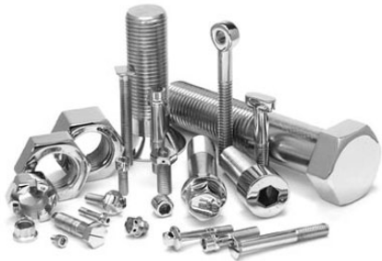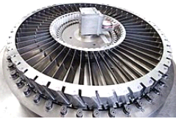

Fasteners, Nut, Bolt, Screw

Vane, various stages Compressor impeller

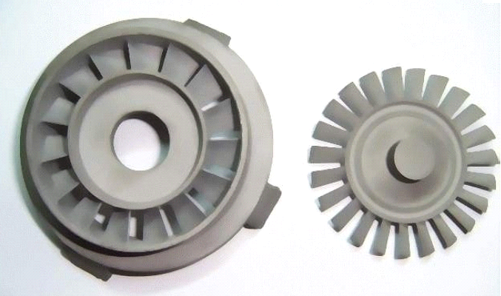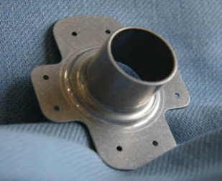

Engine Flanges

Turbine and Impeller

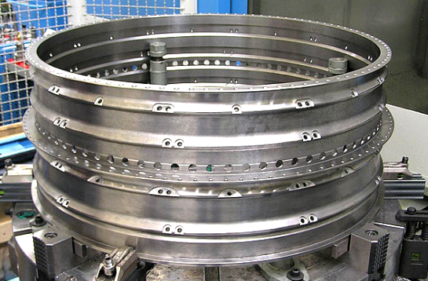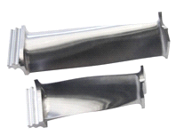

Turbine Blades

Aircraft engine casing Enlarge Aircraft engine casing

Fig. 1.1 Different applications of Inconel 718

Table 1.4 Some industrial application of Inconel 718 [4]

|  |  |
| --- | --- |
| **Applications** | **Components** |
| Gas turbine | Blades, disc, shafts, casing, engine mount, |
| Rocket motor | Exhauster, thrust reverser |
| Pump | Impellers, bodies |
| Space shuttle | Engine part, Exhaust valves, hot plugs, turbo charger |
| Space Station | Pressure vessels of nickel hydrogen batteries |
| Cryogenic | Cryogenic tanks |
| Nuclear Power | Nuclear fuel element spacers |
| Tooling | Hot extrusion tooling |
| Heat treatment | Equipment for heat treatments |

Many components with shape cavities and contours cannot be machined comfortably with plain end milling cutter due to inability to produce the desired radius at the corners however the ball end milling cutter can satisfactorily reach the corner and machine the contours of radii easily.

**1.2 Ball Nose End Milling Cutter**

In the year 1996 first time Ball end mill was introduced and patented by Bjorn Hakansson. Solid Ball nose tool comprising a hard material with 30 – 70 volume % submicron hard constitutes in the form of carbides, nitrides or carbo-nitrides of Ti, Zr, Hf, V, Nb, Ta, Cr, Mo and W in a metallic matrix based on Fe, Co and Ni (as shown in Fig. 1.2) [7]. It has most distinguishing feature like wear resistance and the ability to resist high temperatures at the periphery. Ball end mills are often used in difficult operations where demands are very high in terms of surface finish, for example aerospace industry when milling wing spare, delicate small fastener,etc.

It is also advantageous to use ball end mill in complex mold finishing where surface and accuracy to shape with simultaneous high productivity and predictable long tool life is the requirement.

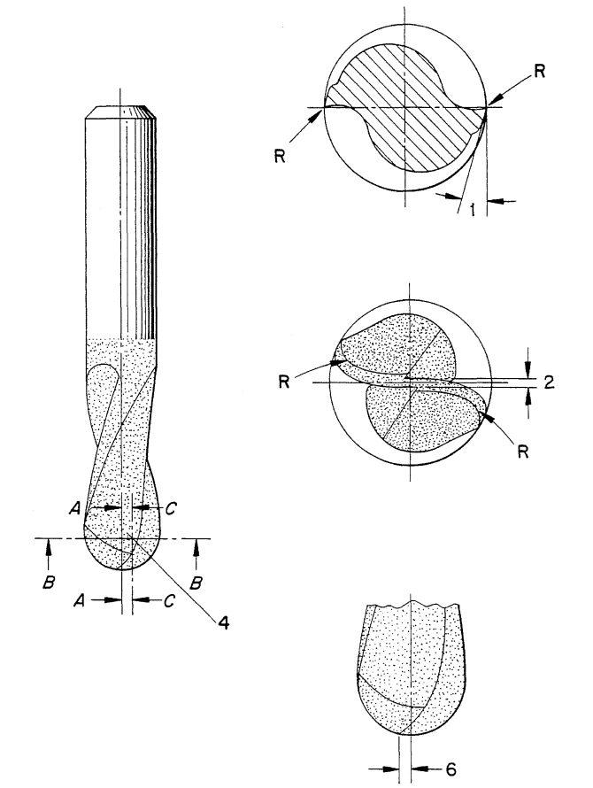



Cross section at A – A



Cross section at C – C

Fig. 1.2 Schematic of solid ball nose end mill [7]

.

**1.3 Surface Integrity**

Surface integrity is the inherent characteristics of the surface generated by the metal working process. It can be quantified in various ways. These are surface topography and sub-surface integrity (see fig 1.4).

Fig. 1.4Surface integrity indicators in machined surfaces

Surface integrity is the sum of all the elements that describes all the conditions exiting on or at the surface of a workpiece. Surface integrity has two aspects. The first is surface topography which describes the roughness, ‘lay’ or texture of this outermost layer of the workpiece, i.e., its interface with the environment. The second is surface metallurgy which describes the nature of the altered layers below the surface with respect to the base of the matrix material [10]. Fig.1.5. depicts a sectional view showing the various layers between the base material and the environment.

Fig.1.5 Various layers of a surface[10]

Surface integrity describes not only the topological (geometric) features of surfaces and their physical and chemical properties, but their mechanical and metallurgical properties and characteristics as well. Surface integrity is an important consideration in manufacturing operations because it influences properties, such as fatigue strength, resistance to corrosion, and service life [11].

**1.3.1 Surface Topography**

Surface topography is quantified by the deviations of the peak and valleys of the surface from their means live of profile. It is basically represented by surface roughness.

It is known that the outermost layers of all machined surfaces display a great number of both macro-geometrical and micro-geometrical deviations from the ideal geometrical surface. Surface roughness refers to deviation from the nominal surface of the third up to sixth order. Order of deviation is defined in international standards. First and second-order deviations refer to form, i.e. flatness, circularity, etc. and to waviness, respectively, and are due to machine tool errors, deformation of the workpiece, erroneous setups and clamping, vibration and workpiece material inhomogenities [10].

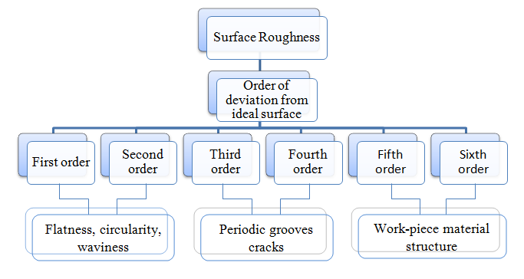

Fig 1.6 Surface roughness forms and its components

Third and fourth-order deviations refer to periodic grooves, and to cracks and dilapidations, which are connected to the shape and condition of the cutting edges, chip formation and process kinematics. Fifth and sixth-order deviations refer to workpiece material structure, which is connected to physical-chemical mechanisms acting on a grain and lattice scale (slip, diffusion, oxidation, residual stress, etc.). Different order deviations are superimposed and form the surface roughness profile (Fig. 1.7).



Fig1.7Surface form deviations [10]

Topography produced by ball-end milled surfaces, considering the tool parallel axis offset [12]. Ball end mills areemployed for finishing machining of sculptured surfaces of dies and moulds. Since these products have very demanding specifications in surface quality, extensive research work has been developed around this operation. Ball end mill produces cups height shapes on the surface during milling.

**1.4 Motivation and Objective**

It is found from the literature on machining of Inconel 718 that the researcher employed conventional as well as non conventional means to understand the machinability of this alloy. But very little researcher work on thin and low rigidity components, it is really difficult to work with small component as they have low rigidity. Still some of the researchers found out relation between force with inclination of workpiece with direction of milling [18, 19]. They found that inclination and direction of cutting really matters on surface produce by milling specifically when is ball nose end milled surface. The above attempt to improve the machinability produce better result in terms of reduction in tool wear, cutting forces and better surface finish and sub – surface integrity. This prompted us to undertake one above techniques and to investigate the surface integrity for thin, delegate and low rigidity superalloy components.

In this study, in order to explore the possibility in improvement of machinability, the machining is done considering multiple objectives.The objectives of the present experimental investigations are –

* To prepare experimental setup for thin plates of Inconel 718.
* To assess the effect of process related (cutting speed, feed rate, cutter path and inclination to workpiece) and the surface integrity.
* To evaluate, the significance of the above input parameters on the output response variable to enhance surface integrity.
* To determine, the strategy to reduce the effect of bending for thin plates.
* Optimization of the process parameter by evolutionary Teaching and learning based optimization (TLBO) method.

**1.5 Organization of the report**

* The project report begins with chapter 1 having introduction of the topic, motivation and objectives.
* Chapter 2 describes the review of the literature on the status of surface quality assessment in the ball end milling of Inconel.
* Chapter 3 explains the experimental setup for investigation done to assess the surface integrity during high-speed ball end milling of Inconel 718.

**CHAPTER 2**

**LITERATURE REVIEW**

This chapter discusses the past research on end milling of inconel 718 as well as similar type of materials. In addition, research on the ball end milling is described in the subsequent sections. The ball nose end milling is a significant key technology of machining for generating precise sculptured surfaces. In order to achieve high-qualified surfaces, some important studies on end milling have been reported. Limited work has been published dealing with the ball nose end milling of Inconel 718 for thin components. Fig. 2.1 presents the scheme of literature review done from open literature. Initial chapter focuses on the introduction of the work material Inconel 718, micro structural properties, machining difficulty, mechanism of ball end milling and surface integrity.

However, systematic review of literature as mentioned in scheme (fig. 2.1) in the latter part.

Surface Integrity

(Micro hardness variation and surface alteration)

Machining Mechanism and Mechanics

(Cutting Forces, Temperature)

Fig. 2.1 Scheme of Literature Review

**2.1 Mechanics and Mechanism of ball end milling**

The cutting speed influences the material deformation into the primary, secondary and tertiary deformation zone. Above critical cutting speed, the dual deformation develops in the primary deformation zone. Among these, intense shear deformation is produced in one of the region, however regions virtually goes deform. This situation leads to intense shear band formation along the narrow deformation zone. There for above the critical cutting speed, thermal softening effect dominate machining of superalloys that intern produce non homogeneous deformation in the body of cheap [13], on the other hand when the cutting speed below its critical value sheared dose not concentrates along narrow band. Hence, more strain hardening occurs in the primary deformation zone, consequently large magnitudes of cutting forces are evident in milling.

Sonawaneet al. [20] has conducted milling of super alloy Inconel 718 by using helical ball end milling. They valid the feed from 0.06 to 0.2 mm per tooth, cutting speed from 25 to 75 m/min, depth from 0.32 to 1mm and cutter path during the experiment. The cutting forces are negligible at start and at some part of end of the cutting operation. Cutting forces are the function of instantaneous shear angle, which in turn is as a function of deformed and undeformed chip dimensions. Fig. 2.2 shows that maximum cutting force in Y- direction compare to other two forces.

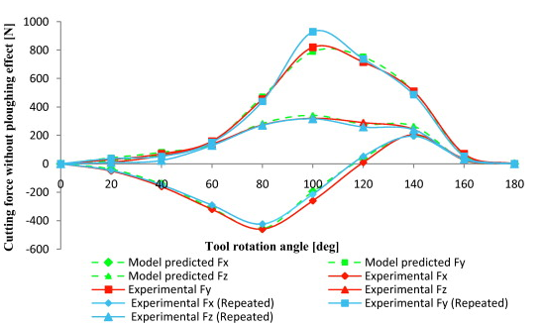

Fig. 2.2 Comparison of experimental and predicted cutting forces in ball end milling of superalloy Inconel 718 without considering ploughing effects [10].

P. Lee et al. (1995) have conducted milling of Ti6Al4V by using flute carbide ball end mill. They varied the feed from 0.0127 to 0.127 mm/tooth during the experiments. It is observed that the higher feed produces highest cutting force. It is also observed from the graph than an increase in depth of cut from 1.27 to 8.89 mm causes increments in cutting force magnitude. It was found that the force pattern in the axial direction is dominated by ploghing action between the flute and the material as soon as the material enters [8].

F. Abrari et al. (1996) have conducted, milling of aluminum by using two types of ball end mill. To asset the effect of number of flute on the milling operation, they used four and flute ball end mill. They varied the cutter path and number of flutes with the constant cutting speed 600 rpm and depth of cut 5.2 mm during the experiments. As far as the cutter path is concerned, the Fy force component was high and positive in up milling. It is observed from the graph that the feed force is minimum in down milling [5].

E – G Ng et al. (2000) have conducted the milling of Inconel 718 by using solid ball end mill, Machining parameters fixed throughout the tests were depth of cut 0.5 mm, feed / tooth is 0.1mm and cutting speed 0 to 210 m/min. It is observed that the higher cutting force was produced when down milling is carried out. It was noticed that with a lower coefficient of friction, cutting forces should be reduced, as there are fewer tendencies for a built up layer to form and lower resistance to chip slide on the rake face. A possible reason for this was the lower mean (64 m/min) and minimum (35 m/min) cutting speed and hence lower cutting temperature that would be expected when machining with the former orientation (minimum cutting speed 66m/min). This would fever increased workpiece/ tool adhesion and built up layer. When machining with horizontal downwards cutter orientation, no vibration observed (Fig. 2.3). Higher cutting forces would also be expected to adversely affect tool life. The lowest cutting forces were measured when employing a horizontal upward cutting orientation (Fig. 2.4 and Fig 2.5)[6].

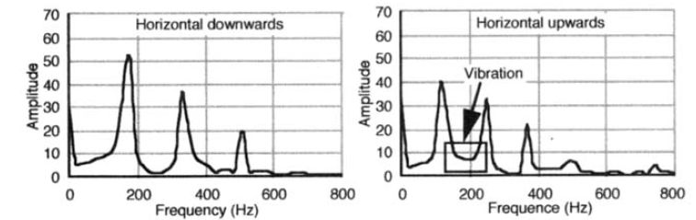

Fig.2.3 Vibration analysis [6]

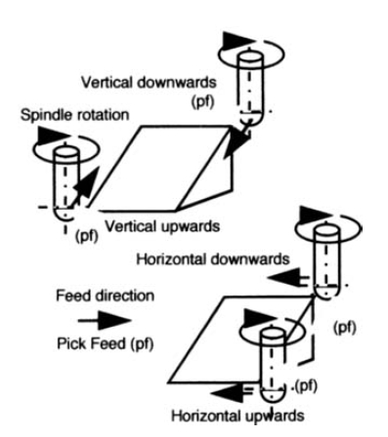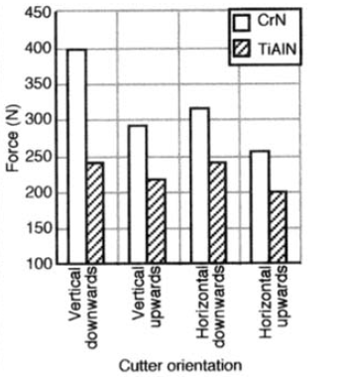

Fig. 2.4 Schematic of cutter orientation [6]

Fig. 2.5 Effect of cutter orientation on specific force and surface roughness [6]

Tai et al. (1994) have conducted milling of AISI 1045 by using ball end mill at higher cutting speed. They varied the feed from 120 to 240 mm/min during the experiments. It is observed that highest feed produced the highest cutting force. As far as the magnitude of cutting force, concerned highest value of cutting force was recorded at high level of process parameter. This increase in cutting force magnitude indicates the run out effect on the tool holder during milling process [4].

E – G Ng et al. (2000) the effect of cutting environment and cutting speed on average length during ball end milling of Inconel 718 cut when using a horizontal down ward cutters orientation with TiAlN (monolayer) coated ball nose end mills (Fig. 2.6). At 150 and 210 m/min cutting speeds, length of cut was extremely short due to premature chipping of cutting edge. The maximum length of cut occurred when 70 bar high pressure-cutting fluid was employed. Thus, found a 123% increase in tool life as compare to machining in dry condition at 90 m/min [6].

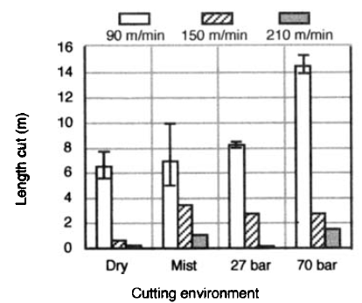

Fig. 2.6 Effect of cutting environment and cutting speed on length cut [6]

Fig. 2.7 shows the effect of cutting environment and cutting speed on the resultant cutting force. Force values increased with the cutting speed for all cutting environment. It is likely that this was due to strain hardening of workpiece. For steel workpiece thermal softening generally counter act the effect of strain hardening and leads to constant forces when cutting speed is varying. This did not occurred here because in the temperature range 200°C to 450°C, the tensile strain of Inconel 718 is constant at 1200 MPa. At a cutting speed of 90 m/min, cutting environment did not have large effect on resultant force, despite measure temperature ranging from 175° (with 70-bar fluid) to 340°C (dry). It is probable that this was due to low variation in the strain across the temperature range. At a cutting speed of 210 m/min, the resultant force was substantially lower for dry and spray mist environment than with 27 and 70-bar fluid [6].

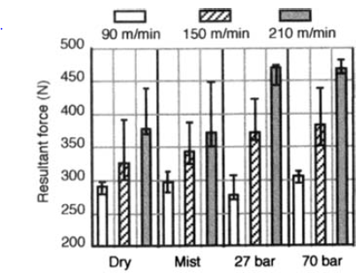

Fig. 2.7 Effect of cutting environment and cutting speed on resultant force [6]

Masahiko Jin et al. (2007) have conducted milling of die steel by using CBN ball end mill. The main cutting condition used were cutting speed 50 to 109.6 m/min, feed 0.03 to 0.075 mm/tooth and depth of cut 0.01 to 0.1 mm, oil mist coolant and down milling. They copaired the performance between the cut depth and cutting force for the super finish ball, nose end mill (SFB), super speed ball nose end mill (SSB) and conventional CBN tools (Fig. 2.8). The feed direction cutting force of the SSB tool was the smallest, but was not markedly different from those of the other tools. The axial of the direction of cutting force of the SSB tool was also the smallest and that of conventional tool was the largest under the small depth cutting condition. On the other hand, that of the SFB tool was the largest under the large depth cutting condition. In case of the SSB tool, the axial direction cutting force was approximately 70% smaller than those of the other tool were. When the axial direction and feed direction cutting forces compared, the axial direction cutting force was found to be twice the feed direction cutting force [4].



Fig. 2.8 Relationship between depth of cut and cutting force for the SFB,SSB and CB.

(a) Feed-direction force (*P*c) and (b) axial-direction force(*P*t) (workpiece: SKD11 (60HRC)

*n* = 40,000 min−1, *v* = 50*.*0–109*.*6 m/min,*d*r = 0.05 mm, *S*t = 0.05 mm/tooth, oil mist) [23].

AbdullahiAzeem et al. (2004) have conducted milling of SAE 1018 cold rolled steel by using coated carbide ball end mill. They used only two flutes ball nose end mill to simplify and calibration of a mechanistic cutting force model. The machining test was performed without coolant at a spindle speed of 948 rpm. A table feed rate of 101.6 mm/min (0.054mm/tooth) was employ to reduce the machine vibration due to relatively non rigid rotary axis structure. It was observed from the graph (Fig. 2.9) that the cutting and feed force increases with increase in the feed. The magnitude of the cutting force is low as compare to feed force during machining [3].

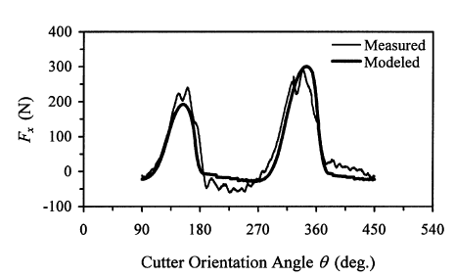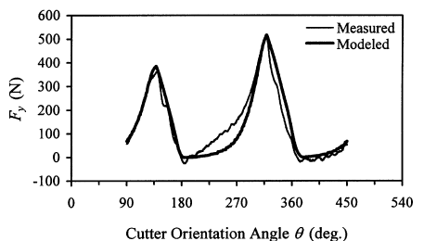

Fig. 2.9 Modeled and measured x and y cutting forces [3]

Matjaz et al. (2003) have conducted milling of superalloy CK45 by using ball end milling cutter. They varied the feed from 0.025 to 0.2 mm/tooth, cutting speed 250 to 500 mm/min with depth of cut 2 to 8 mm during the experiments. At the higher feed, the magnitude of feed force is high as compare to cutting force and thrust force. As increases in the depth of cut, the magnitude of the feed force increases as compared to thrust and cutting force. As far the cutting speed is concerned, at lower cutting speed, the magnitude of feed force is high as compared to other forces (fig. 2.10) [2].

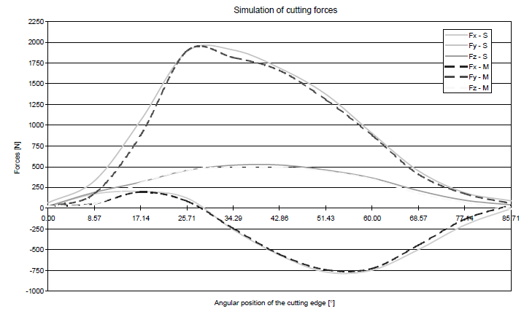

Fig. 2.10 Representation of measured ( Fx – M, Fy – M, Fz – M) and

simulated (Fx – M, Fy – M, Fz – M) cutting forces, Ball – end milling cutter [2].

K.-D. Bouzakis et al. (2003) have conducted milling of cast steel GS 45° by using ball end mill. They performed experiment with the fix parameters as cutting speed 50 to 70 m/min, feed 0.2 mm/rev and depth of cut 0.3 mm. An increase in the feed rate leads to a magnification of cutting force components. The tool deflections caused by the cutting force during finishing are significant surface topography (Fig. 2.11) [2].



Fig. 2.11 Calculated and measured cutting force components in differentmilling kinematics [2].

JuspreetDhupia et al. (2012) have conducted milling on modified AISI 420 stainless steelwithout coolantusing ultra micro grain carbide ball-end mill, (Al,Ti)N-coated, having two flutes and radius of 3mmon a vertical milling machine with spindle speed of 1120 RPM, feed rate of

150mm/min, and depth of cut of 0.5mm.They carry out comparison between the estimated cutting coefficientsobtained from the first contact and the correlation-based leastsquares approach applied to force data from a slot-milling test on STAVAX. They found that as more normal pressure was exerted on the tool while machiningthe hard and ductile STAVAX material, the order of Kn and Knfishigher compared with that of other coefficients. Due to this higher order,discrepancies in estimation become more apparent for the normal coefficientsas compared with the frictional counterparts. The comparison of estimated and experimental forces are as shown in fig. 2.12 [2].



Fig. 2.12 Estimation of forces excluding axial force Fz [2].

**2.2 Surface Integrity of Ball End Milling**

**2.2.1 Effect of Machining Parameter on Surface Roughness and Residual Stress**

Surface roughness plays an important role in the performance of a finished part. Surface roughness generated in machining operations isinfluenced by an enormous set of factors such as cutting parameters, cutting tool characteristics, workpiece properties, or cutting phenomena.Cutting geometric characteristics, when ball end mill is used, clearly affect surface crests generated.

G. Quintana et al. (2010) have studied the influence of thegeometric characteristics of ball end mill cut on the theoretical surface roughness obtained. They have conducted experiment on hardened AISI H13 and calculated crest height ‘h’ on the surface as a function of calculated as function of cutting toolradius (R) and radial depth of cut (Ae), considering also, the surface angularity (Fig. 2.13). It is observed that Ra is directly depends on ratio of depth of cut to tool radius, as the ratio is towards to minimum side, Ra value is also tends to minimum and goes on increasing as value of ratio increases (Fig. 2.14) [3].



Fig. 2.13 Cups height variation [3]

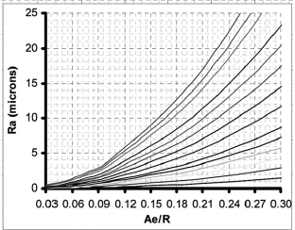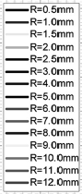

Fig. 2.14 Surface roughness variation [12]

Arizmedi et al. [12] developed an analytical model for the prediction of surface topography generated by ball end milling run out. It is assumed that the run out is due to a parallel offset between the tool and the spindle axes. The model is developed considering tool parallel axis offset, cutting edge trajectories and the material swept by the tool. Fig. 2.15 to Fig. 2.18 shows the measured and predicted topography of surface milled with the two offsets and different strategies. In Fig. 2.15 and Fig. 2.17, milling strategy is zig – zag. Fig 2.16 and Fig. 2.18, milling is performed only in the feed direction. From the analysis of the measured topographies and images from SEM (part a and b in Fig. 2.15 to Fig. 2.18), it is observed that, between two paths, cups are delayed due to the fact that angular position of cutting edges in the entrance of cut different, as it was reported in [1]. This difference is taken into account in the model. Comparing the measured surface (a) and the image (b) with the predicted one (c), it can be seen that they agree the reasonably well in shape. The influence of strategy is manifested in the existence of a scallop in zig – zag strategy that does not appear when milling in one direction.

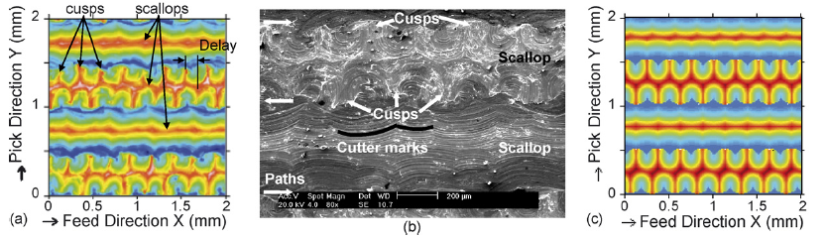

Fig. 2.15 Measured (a and b) and predicted (c) surface milled in zig – zag with ρ = 3 µm and λ=90° [12]

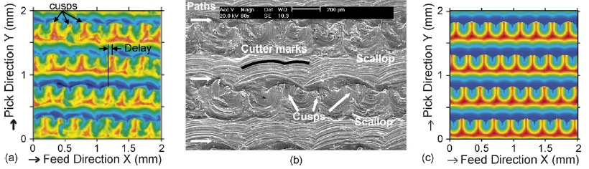

Fig. 2.16 Measured (a and b) and predicted (c) surface milled in one direction with ρ = 3 µm and λ=90° ( f = 0.5 mm, ae = 0.5 mm). [12]

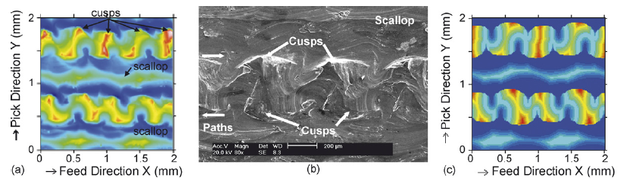

Fig. 2.17 Measured (a and b) and predicted (c) surface milled in zig – zag with ρ = 53 µm and λ=22.5° ( f = 1 mm, ae = 0.5 mm). [12]

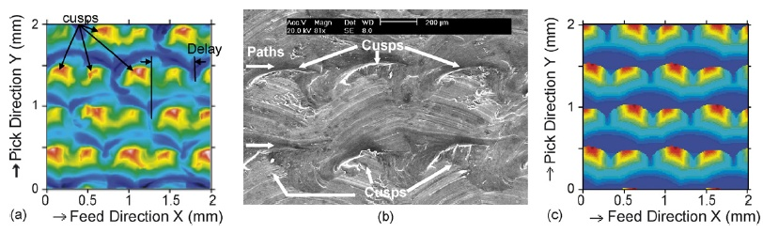

Fig. 2.18 Measured (a and b) and predicted (c) surface milled in one directionwith ρ = 53 µm and λ=22.5°( f = 1 mm, ae = 0.5 mm). [12]

The influence of the offset is manifested in that, for small offset value (Fig 2.15 and 2.16), cups, valley between cups and scallops along the feed direction are uniform in shape but, for the large offset values, valleys and scallops are not uniform. The influence of the angular position in the entrance of large offset in zigzag milling (Fig. 2.17) is manifested in that cups are different( the once at the top are oriented to the right and the once at the bottom are orient to the left) and scallops have a waviness along the feed direction. When offset is small, (Fig. 2.15) cups are similar and scallops are straight. As it can be observed, the influence of the three parameters studied above (strategy, axis offset and entrance angle) is very similar on the both the measured and predicted surfaces therefore it can be concluded that the model results agree reasonably well with the experimental ones [12].

Jin et al. (2007) have conducted the milling of die steel by using CBN ball end mill. Fig. 2.19 shows the relationship between cutting distance and cutting surface roughness for super finish ball nose end mill (SFB), Super speed ball nose end mill (SSB) and conventional CBN tools. At the finish machining conditions for light cutting, the axial – direction cutting depth da, radial – direction cutting length dr and feed per edge St were set at 0.02 mm, 0.05mm and 0.03 mm/ edge respectively. As a result, in the cutting distance range of 0 to 1200 m, the surface roughness of the steel machined using the SFB tool was smallest, followed by that of the steel machined using the SSB tool, and the surface machined using the conventional CBN tool was the roughest. Because the cutting edge of SFB had the shape of a continuous are as mentioned above, the highest machining tool accuracy and a high cutting performance of the web were realized. In the case of the SSB tool, on the other hand, the surface roughness was slightly larger than that obtained using the SFB tool due to the presence of the web. However, because the SSB tool had no chamfer differently from the conventional tool, a high cutting performance and a high machining tool accuracy were realized, improving the surface roughness compared with that obtained using the conventional CBN tools.

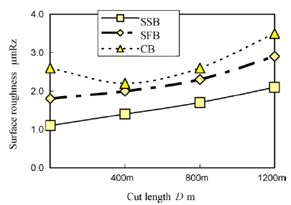

Fig. 2.19 Relation between cutting distance and cutting surface roughness [12]

Bouzakis et al. [26] studied the effect of milling kinematics and the contact conditions between the tool and the workpiece surface topography in multi axis finish milling with ball end mills. Algorithm were developed considering the movements of the cutting tool and the workpiece due to the milling kinematics, the undeformed chip geometry, the cutting force components the tool deflection and the final surface topography expected are determined (Fig.2.20).

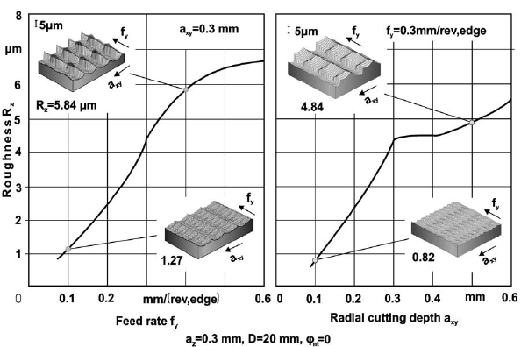

Fig.2.20 Workpiece surface topography for various feed rate and thrust cutting depths, by means of the determined ball mill algorithm [2].

R.M. Arunachalam et al. [2] have conducted experiment the milling of solution annealed and precipitation hardenedInconel 718 (35 RC) using tools shown in Table 2.1.

Table 2.1 Specifications of the cutting tools

|  |  |  |  |  |  |
| --- | --- | --- | --- | --- | --- |
| Substrate | Type of coating | Insert Specification | | | Tool code |
| Nose radius | Edge preparation | Insert rake type |
| Fine grained | PVD-TiAlN | 0.8 | Chamfered | Negative | A1 |
|  |  | 0.8 | Positive sharp | Negative | A2 |
|  |  | 1.2 | Chamfered | Negative | B |
|  |  | 1.6 | Chamfered | Negative | C |
| Fine grained | PVD-TiAlN | 0.8 | Positive sharp | Positive | D |
| Fine grained | CVD-TiCN/Al2O3/TiN | N/A | Honed | Positive | R |

Surface finish have the effect of cutting toolparameters such as insert shape, cutting edge preparation,insert rake type, nose radius, and the effect ofcoolant. It was found that trend for dry and wet cooling is same. The effect of square and round insert shapes on thesurface finish is shown in Fig. 2.21. For a round inserts lower surface finish observed since the contactlength of the tool is large compared to a square insertand so the height of the feed marks (cusp height) arereduced, resulting in lower Ra values and trend for dry and wet cooling is same.

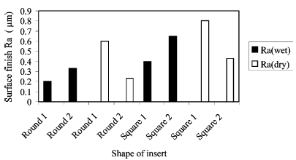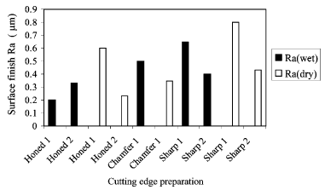

Fig. 2.22 Effect of cutting edge preparation on surface roughness[Honed-R (positive rake); Chamfered-A1 (negative rake);Sharp-A2(negative rake)].

Fig. 2.21 Effect of insert shape on surface roughness [Round-R (positiverake); Square-A2 (negative rake)] [2].

Effect of insert also have been studied and it clearly shows that round inserts producedcompressive residual stresses while square inserts producedtensile residual stresses in wet cutting conditions (Fig. 2.23).The compressive residual stresses produced by roundinserts in the case of wet cutting conditions may be dueto the higher cutting forces generated which in turnresults in the dominance of plastic deformation as indicatedby the light feed marks and absence of smeared material.

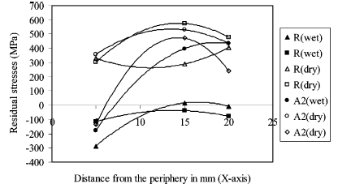

Fig. 2.23 Effect of insert shape on residual stresses [Round-R (positiverake); Square-A2 (negative rake)].

**2.3 Process modeling and optimization**

Anayet U. Patwari et al. [3] have conducted experiment on Stainless steel (SS304) using end milling. Response surface methodological approach for the prediction of tangential cutting force produced in end-milling operation was adopted. Mathematical models suggested could adequately describe the performance indicators within the limits of the factors that are being investigated. The quadratic CCD indicate that the feed was the most significant influence on Cutting force, followed by depth of cut and cutting speed. An increase in either the feed or the axial depth of cut increases the Cutting force, whilst an increase in the cutting speed decreases the Cutting force. The CCD model developed by RSM using Design Expert package is able to provide accurately the predicted values of Cutting force close to actual values found in the experiments.

P. J. Pawar et al. [3] have developed mathematical model using Response surface modeling approach for correlating the relation of various wire electric discharge machining parameter with a performance measure. A nontraditional optimization technique known as partical swarm optimization is then applied to model for optimizing the parameter.

**2.4 Conclusions from Literature Review**

* In the open literature, it is found that the ball end milling produces small force magnitude as compared to plain end milling operation.
* Further orientation of workpiece with respect to ball end mill is very important to reduce the cutting force and subsequent surface quality.
* No study has been reported on cantilever shaped component.
* Hardly any work has been reported on machining of low rigidity or thin shape components, very few authors have tried it, and no one reported issues related to surface integrity.
* Inadequate work is available on mathematical modeling of ball end milling process by using response surface method and its hybrid non conventional optimization.

**CHAPTER 3**

**EXPERIMENTAL WORK**

**3.1 DESIGN OF EXPERIMENT-TAGUCHI APPROACH**

The goal of Taguchi method is to find control factors settings that generate acceptable responses despite natural environmental and process variability. Much of the Taguchi method is traditional is orthogonal arrays are two level, three-level and mixed level fractional factorial designs. The purpose of the Taguchi method was to develop products that worked well inspite of natural variations in materials, operators, suppliers and environmental change. This is robust engineering. Taguchi methods use the traditional orthogonal arrays such as L4,L8 and L16.the steeps involved in typical L8 arrays are as follows.

* Choose the variables you wish to examine.In the following case six variablesand one interaction.
* Choose two levels for each main variable.
* Assign variables to the columns of a Taguchimatrix.Appropriate columns are left blank for particular interactions, in case column C for interactions AB.
* Carry out the work according to the positives and negatives of each row. Generally positive (+) is the higher level and negative (-) is the lower level.
* Substitute the values of output variables in the result column.

**3.1.1 Selection of input parameters**

The input process parameters were selected based on the literature review and the previous experimental work of the authors. The cutting speeds are planned to be used in 2000 to 4000 rpm. i.e. high speed milling for Inconel 718. The cutting feed is used in the range of 0.05 to 0.1 mm/tooth. The orientation used is 15º and 45º for both horizontal and vertical milling. For experimental work two plates were used of thickness 4mm and 7mm.

**3.1.2 Selection of Response Variables**

In order to explore the effect of workpiece orientation and thickness on the ball and milling performance, the following response variables were chosen;

1. Surface roughness

Surface roughness consists of fine irregularities in the surface texture, usually including those resulting from inherent action of the production process, such as feed marks produced during machining.

1. Machining force components:

The machining forces during milling have three components they are axial, radial and cutting forces.

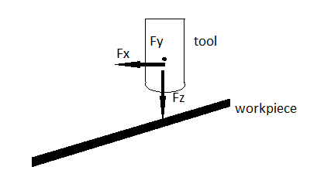

Fig.3.1 The workpiece tool and force components

**3.1.3 Selection of Orthogonal Array**

Table 3.1presents a standard L8orthogonal array proposed by Taguchi. The selected values of the input process parameters were substituted in the factor column of the standard orthogonal array and are presented in this table 3.2 forworkpiece with 150 inclination to the machine table and table 3.3 shows the actual values of the process parameters for the 450 inclination angle provided to the workpiece.

Table 3.1 Standard array of L8

|  |  |  |  |
| --- | --- | --- | --- |
| Factor 1 | Factor 2 | Factor 3 | Factor 4 |
| 1 | 1 | 1 | 1 |
| 1 | 1 | 2 | 2 |
| 1 | 2 | 1 | 2 |
| 1 | 2 | 2 | 1 |
| 2 | 1 | 1 | 2 |
| 2 | 1 | 2 | 1 |
| 2 | 2 | 1 | 1 |
| 2 | 2 | 2 | 2 |

Table 3.2 Actual array of L8 with 15º inclination angle

|  |  |  |  |
| --- | --- | --- | --- |
| Spindle speed  Vc(rpm) | Feed  (mm/tooth) | Orientation  (◦) | Thickness  (mm) |
| 2000 | 0.05 | 15˚V | 4 |
| 2000 | 0.05 | 15˚H | 7 |
| 2000 | 0.1 | 15˚V | 7 |
| 2000 | 0.1 | 15˚H | 4 |
| 4000 | 0.05 | 15˚V | 7 |
| 4000 | 0.05 | 15˚H | 4 |
| 4000 | 0.1 | 15˚V | 4 |
| 4000 | 0.1 | 15˚H | 7 |

Table3.3 Actual array of L8 with 45˚ inclination angle

|  |  |  |  |
| --- | --- | --- | --- |
| Spindle speed  Vc(mm) | Feed  (mm/tooth) | Orientation  (◦) | Thickness  (mm) |
| 2000 | 0.05 | 45˚V | 4 |
| 2000 | 0.05 | 45˚H | 7 |
| 2000 | 0.1 | 45˚V | 7 |
| 2000 | 0.1 | 45˚H | 4 |
| 4000 | 0.05 | 45˚V | 7 |
| 4000 | 0.05 | 45˚H | 4 |
| 4000 | 0.1 | 45˚V | 4 |
| 4000 | 0.1 | 45˚H | 7 |

**3.2 Work material,Tooling,Equipment**

**3.2.1 Work Material**

In this experimental work, the Inconel 718 was selected as the work material. The workpieces were obtained in the form of rolled plates of 4mm and 7mm thickness.The dimensions of the workpiece used for the experimental purpose are 75mm×25mm×4mm&75mm× 25mm×7mm. The flattening of the workpiece material was done using hand operated press.

As the work material is in the rolled condition, it needs to be stress relieved for eliminating the internal residual stresses beneath the surface. Therefore, the heat treatment given below was carried out.The heat treatment was performed in Dura Magnet PVT. Ltd, Satara. The chemical composition of the work material was tested using a Spectroscopy test.

|  |  |  |  |
| --- | --- | --- | --- |
| Furnace | Temperature | Time duration | Cooling |
| Muffel furnace | 9540C to 9820C | 1hr | Air cooled |
| Muffel furnace | 7180C | 8hrs | Air cooled |

**Chemical composition of inconel 718**

|  |  |  |
| --- | --- | --- |
| **Elements** | **Values from standard ASM handbook (weight %)** | **Values as tested**  **(weight%)** |
| Nickel | 50.00 -55.00 | 51.50 |
| Chromium | 17.00 -21.00 | 20.00 |
| Manganese | 0.35 | 0.30 |
| Silicon | 0.35 | 0.30 |
| Carbon | 0.08 | 0.08 |
| Molybdenum | 2.8-3.3 | 2.9 |
| Titanium | 0.3 | 0.3 |
| Phosphorous | 0.015 | 0.015 |
| Sulfur | 0.015 | 0.015 |
| Aluminium | 0.65-1.15 | 0.95 |
| Boron | 0.006 | 0.005 |
| Cobalt | 1.00 | 0.95 |
| Niobium | 4.75-5.5 | 5.10 |
| Copper | 0.2-0.8 | 0.6 |
| Iron | balance | 17.00 |

1. **WorkMaterial**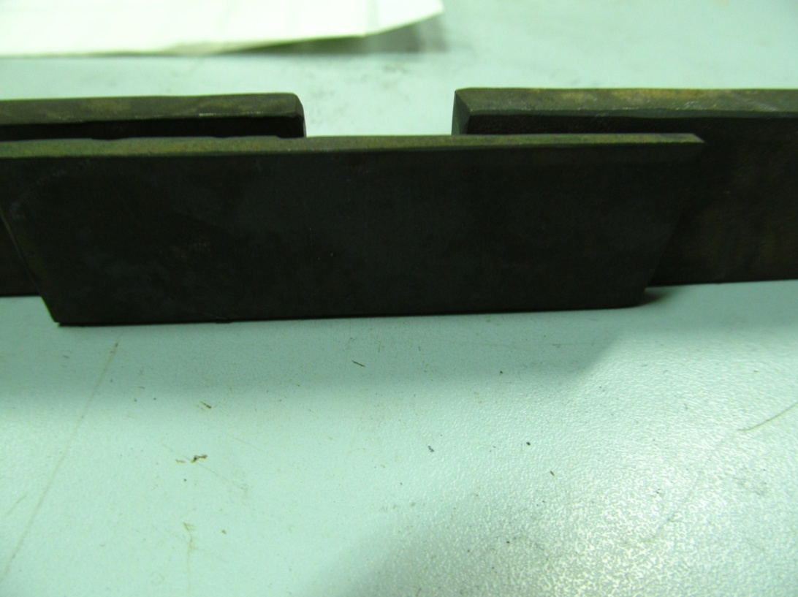

7mm thick

4mm thick

Fig. 3.2 Workpiece before machining

**3.2.2 Tooling**

**Ball nose end mill**

* Ball end mill: The ball end milling process is similar to end milling but cutting occurs at the curved end ,rather than the straight periphery, of the cutter.Ball nose end milling is primarily used to machine dimensional contours on molds,dies,and similar parts where sharp corners must be avoided. It is also used for shallow slots and pockets to produce a radius in the bottom of slot or pockets for added strength.
* Two Flute: The two-flute end mill has the greatest amount of flute space allowing for more chip carrying capacity as compared to single flute end mill. Used primarily to machine slots and pockets in non-ferrous materials where chip removal is a major concern.



Fig 3.3A schematic of ball nose end mill geometry

**Geometry and angles of end milling cutter**

The various angles of the ball end milling cutter is defined as follows

* **Radial rake angle**

It is measured between blade faces and radial reference plane drawn from cutter axis and cutting edge. Normal radial rake is measured perpendicular to cutting edge. The value of radial rake is chosen depending on the workpiece material and cutting tool material ,positive rake cutting edge peels the chip away from the work so there are chance of breakage of cast iron parts ;especially having thin and fragile section. Negative rake gives strength to the cutting edge and has favorable contact on tooth face,but produce higher forces and increased power. Ina rough estimation,change of positive rake to negative rake by 100 causes 1% increase in cutting forces.

* **Axial rake angle**

It is the inclination of cutting edge with respect to axis of cutter and this angle is responsible for direction of chip flow. If axial rake is positive,chip have a tendency to come out of the cut. Negative rake causes forcing of chip towards workpiece.

* **Helix angle**

The function of the helix angle is to direct the chip and provide the curl to the chip. The helix angle also influences the point of impact of the job .If helix angle is not there in a cutter and the cutting edge are straight the entire edge comes into contact with the job and the chip cross section gradually increased and drops to zero when the tooth is disengaged. This results in severe fluctuation of the forces. When milling with a helix angle the cutting edge sweeps across width of the job in a diagonal.A high helix angle generally around 450 is also generates an desirable. The helix helps move chip up and out of the cutting zone and generates an excellent surface finish.The helix angle also helps soften the impact at entrance of cut resulting in a smoother and quieter cut.

* **Approach angle**

It is an angle between plane perpendicular to cutter axis and plane tangent to surface of revolution of cutting edge. As approach angle decreases,load on cutting edge is distributed over a longer length of cutting edge.This decreases thermal stress and thus increases tool life .When the feed is kept a constant value .as approach angle is increased the chip thickness is also increased .But as the approach is decreased , load on cutting edge is distributed over a longer length of cutting edge,which cause decreased thermal stress along with tool life reduction.

* **Clearance angle**

Side clearance is the angle between cut surface and clearance flank on cutter. For reducing wear,large clearance value is considered but high values causes the weakening of cutting edge which gets overheated of poor heat transfer.Clearance angle depends on diameter of end mill. As much as larger is the diameter,smaller needs the clearance angle.All of above angle have a role to play in milling operation.

**Geometrical model for a Ball end mill**

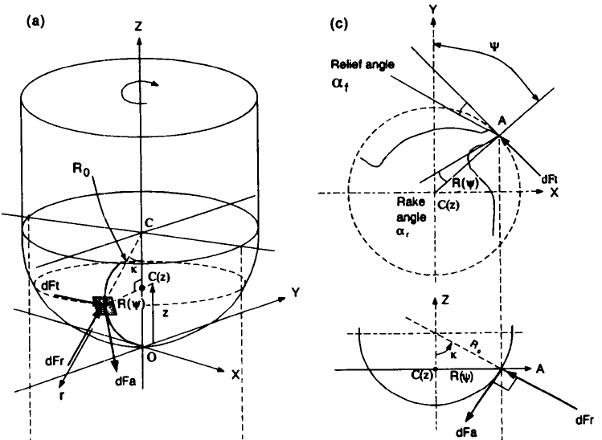

Fig. 3.4 Geometrical model for ball end mill

*x*2 *+ y*2 *+ (Ro - z)* 2 *= Ro*2  (1)

*R2(z) = x2 + y2* (2)

where, ψ is the lag angle between the tip of the flute at *z* = 0 and at axial location *z*, and it is due to the helix angle ψ is measured clockwise from the +y-axis, see Fig. 1.3 (b). The centre of the local coordinate system coincides with the global coordinate system *X-Y-Z* on the dynamometer shown by ball tip point θ in the figure.

**3.2.3 Machinery and measuring instrument**

**1. Vertical milling Machine (VMC)**

The machine tool on which the machining will be carried out is VMC machine.

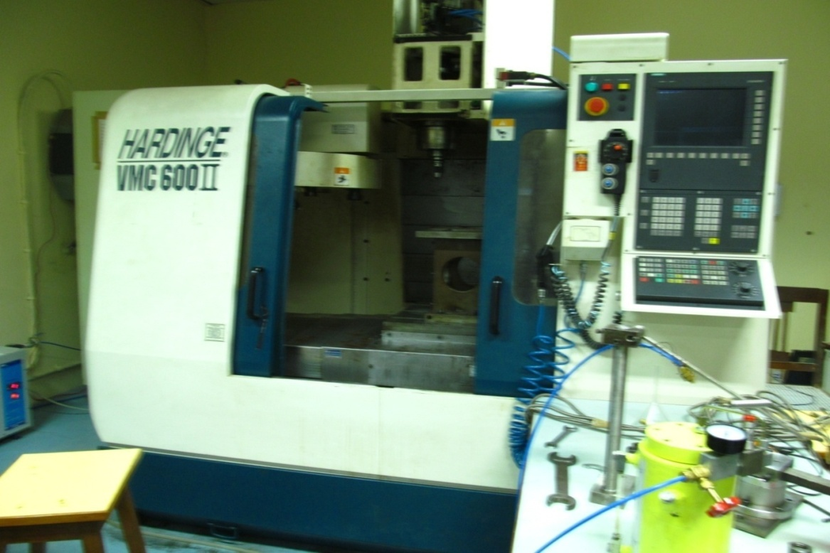

Fig.3.5Photograph of VMC Machine

**Technical specification of the VMC**

Table 3.5 VMC specification

|  |  |  |
| --- | --- | --- |
| Machine specification | Item | Hardings 600 II |
| Travel | X axis travel  Y axis travel  Z axis travel | 600 mm  530 mm  510 mm |
| Table | Working surface  Table loading capacity | 900×600 mm  500 kg |
| Spindle | Max. spindle speed | 8000 min-1 |
| ATC | Type of tool shank  Tool storage capacity | BT 40  20 |

1. **Surface Roughness Tester**

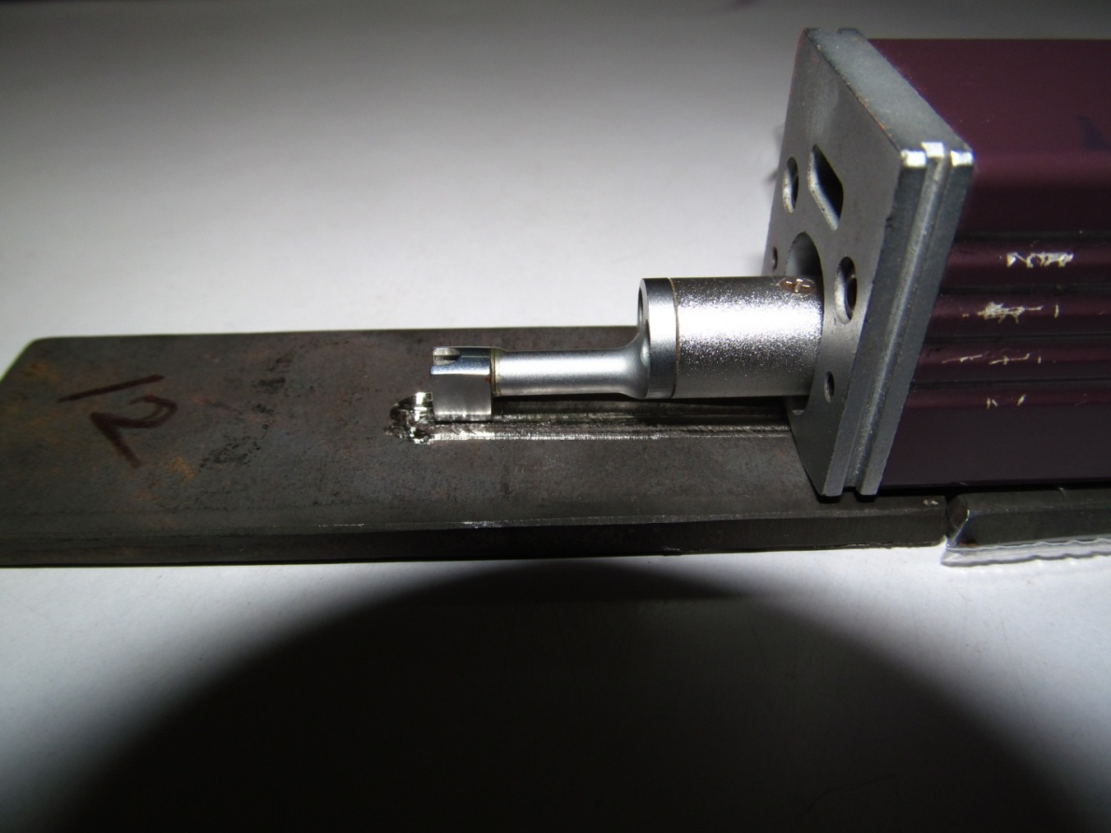

Fig. 3.6 Roughness Testing

Surface roughness will be measured by using surface roughness tester. This tester was manufactured byMitutoyosurftestSJ-301 surface roughness tester are as follows.

Table 3.6 Technical specifications of Surface roughness tester

|  |  |
| --- | --- |
| Parameter | Ra |
| Filter | 2R-C type |
| Cut off length | 0.08, 0.25, 0.8, 2.5mm |
| Resolution (vertical) | 0.01µm |
| Tip radius | 5µm, 2µm |
| Stylus material | Diamond |
| Radius of skid curvature | 40mm |

**3. Deflection Sensor**



Fig.3.7 photograph of deflection sensor

Table 3.7 Technical Specifications of deflection sensor

|  |  |
| --- | --- |
| RPM(revolution) | 60 ~ 99,990r/min |
| Frequency | 1 ~ 20KHz |
| Standard Accessory | Magnet, Accelerometer, Stinger probe  (Cone), Stinger Probe (Ball) |
| Accessory | HTC RS-232 Cable with Software, RS-232 USB Cable |
| Dimensions | 124 x 62 x 30mm |

**4. Experimental Setup**

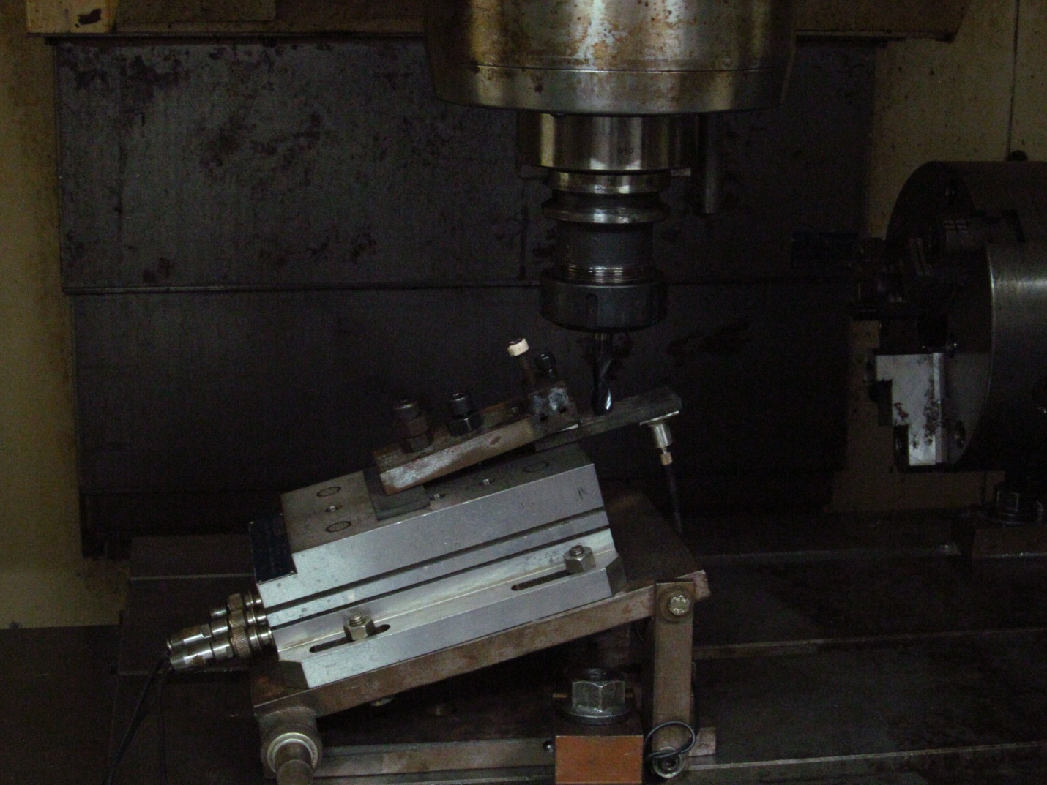

KistlerDyanamometer

Fixture

Deflection sensor

Workpiece

Ball end mill

Fig 3.8 Experimental set of Ball nose end mill with inclined plate.

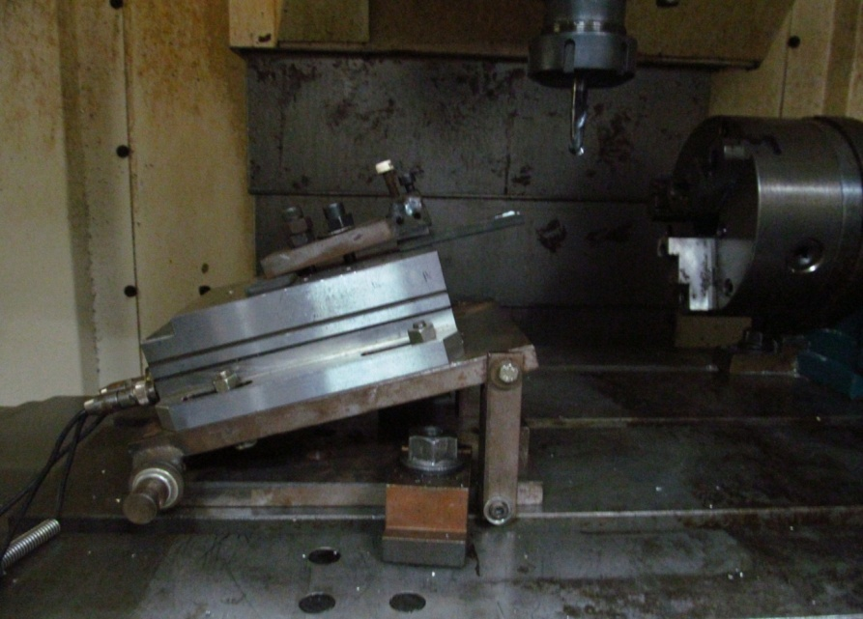

Fig 3.9.Setup of ball nose end mill with 15˚inclined plate

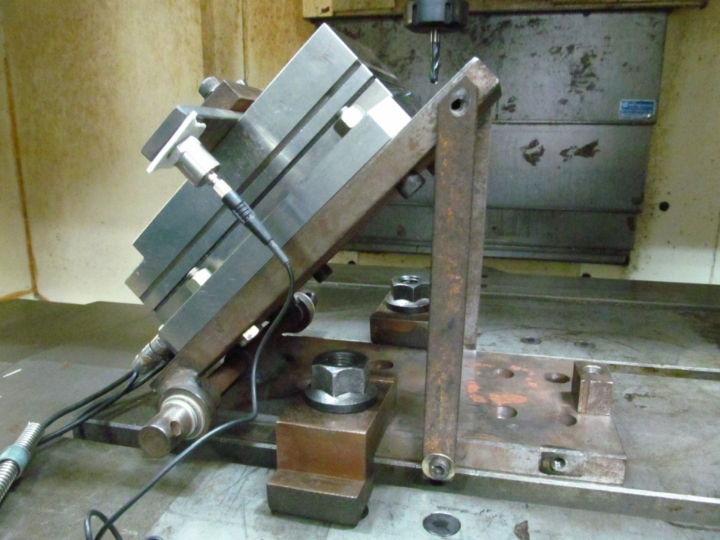

Fig 3.10Setup of ball nose end mill with 450 inclined plate

**FIXTURE**

It consists of two base plates which made up of mild steel. Arrangement is made to adjust the angle between two plates. The fixture has workpiece holding arrangement. The fixture required to keep the workpiece plate is fabricated inhouse and fixed clamped on the machine.

**EXPERIMENTAL PROCEDURE**

* The arrangement of fixture is done as shown in Fig. 3.7, 3.8 and 3.9.
* The deflection sensor is attached to the workpiece at the end side using two sided tape.
* The connectionof the Kistler dynamometer is made up with interface with the help of connection wires.
* The workpiece is fitted in the fixture.
* The suitable program is imparted which includes the valuation of feed, speed and depth of cut.
* The milling process is done with horizontal or vertical orientation.

**3.2.5Measurement of output variable**

**Surface roughness**

After the ball end milling operation, the workpieceswere tested for the surface roughness. Mitiutoyo roughness tester was used for this purpose. The stylus tester traces the minute irregularities of the workpiece surface. Surface roughness is determined from the vertical stylus displacement produced during detector traversing over the surface irregularities. The measurement results are displayed digitally on the touch panel.

**Forces produced in inclined plate**

During the milling operation the data for the forces produced on the workpiece is acquired by the Kistlerdynamometer in three directions that is radial axial and vertical cutting(FzFyFx). The dynamometer was connected with the interface using connecting cables. After machining the values of forces in three directions that is radial axial and vertical cutting(FzFyFx) are simultaneously obtained on the display.

**CHAPTER 4**

**RESULTS AND DISCUSSION**

**4.1Statistical Analysis of Surface Roughness Ra for 15º inclination**

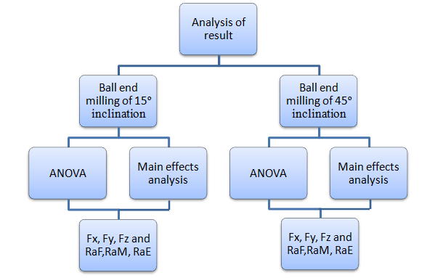In order to meet the objective of the experimental study, the data recorded during ball end milling experiment was analyzed using Taguchi statistical approach. The result of the analysis is presented in terms of main effects plots, analysis of variance and normal probability plots and regression.

Figure 4.1 Flow chart showing analysis of results

Table 4.1 Responses for surface roughness Ra and forces with 15º inclination

|  |  |  |  |  |  |  |  |  |  |
| --- | --- | --- | --- | --- | --- | --- | --- | --- | --- |
| Speed  (rpm) | Feed (mm/ tooth) | Orientation(º) | Thickness  mm | RaF  µm | RaM  µm | RaE  µm | Fx  N/V | Fy  N/V | Fz  N/V |
| 2000 | 0.05 | 15v | 4 | 4.63 | 1.34 | 3.84 | 300 | 280 | 480 |
| 2000 | 0.05 | 15h | 7 | 6.31 | 0.31 | 5.17 | 340 | 245 | 456 |
| 2000 | 0.1 | 15v | 7 | 8.13 | 5.03 | 2.78 | 172 | 172 | 316 |
| 2000 | 0.1 | 15h | 4 | 2.04 | 0.91 | 1.13 | 106 | 108 | 188 |
| 4000 | 0.05 | 15v | 7 | 2.61 | 2.43 | 0.75 | 76 | 44 | 600 |
| 4000 | 0.05 | 15h | 4 | 1.13 | 1.36 | 0.59 | 120 | 124 | 216 |
| 4000 | 0.1 | 15v | 4 | 4.63 | 1.82 | 2.12 | 180 | 136 | 560 |
| 00 | 0.1 | 15h | 7 | 6.03 | 13.23 | 3.29 | 374 | 48 | 140 |

RaF=Surface roughness at fixed end

RaM= Surface roughness at middle

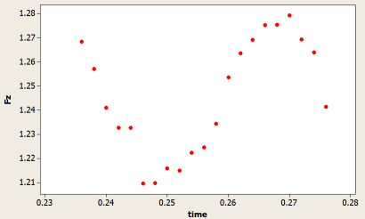RaE= Surface roughness at end

Fx= Tangential force

Fy=Radial force

Fz= Axial force

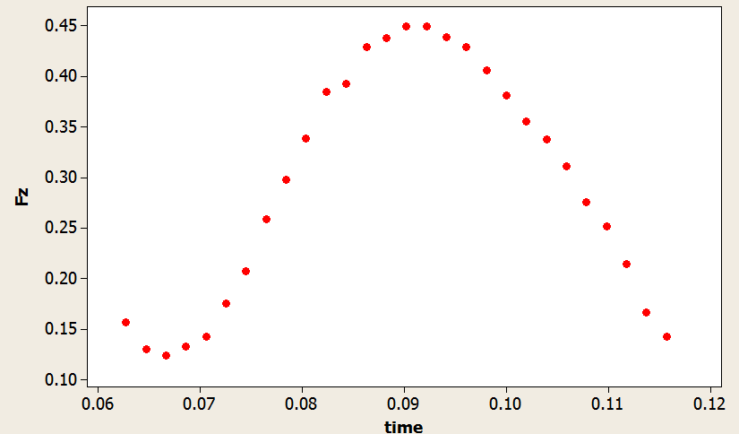

Graph 4.1 - Fz V Time in 15º inclination Graph 4.2 Fz V Time in 15º inclination

4.1 Analysis of ball end milling for 15º inclination angleANOVA analysis for forces at 15º

Table 4.3 ANOVA of Fy

|  |  |  |  |  |  |
| --- | --- | --- | --- | --- | --- |
| Source | DF | Seq SS | Adj MS | F | P |
| Speed | 1 | 13122.0 | 13122.0 | 13.54 | 0.035 |
| Feed | 1 | 19012.5 | 19012.5 | 19.62 | 0.021 |
| Orientation | 1 | 3042.0 | 3042.0 | 3.14 | 0.175 |
| Thickness | 1 | 3612.5 | 3612.5 | 3.73 | 0.149 |
| Error | 3 | 2906.5 | 968.8 |  |  |
| Total | 7 | 41695.5 |  |  |  |
| S = 31.1261 R-Sq = 93.03% R-Sq(adj) = 83.73% | | | | | |

Table 4.4 ANOVA of Fz

|  |  |  |  |  |  |
| --- | --- | --- | --- | --- | --- |
| Source | DF | Seq SS | Adj MS | F | P |
| Speed | 1 | 27966.1 | 27966.1 | 145.06 | 0.001 |
| Feed | 1 | 946.1 | 946.1 | 4.91 | 0.114 |
| Orientation | 1 | 7260.1 | 7260.1 | 37.66 | 0.009 |
| Thickness | 1 | 0.1 | 0.1 | 0.00 | 0.981 |
| Error | 3 | 578.4 | 192.8 |  |  |
| Total | 7 | 36750.9 |  |  |  |
| S = 13.8849 R-Sq = 98.43% R-Sq(adj) = 96.33% | | | | | |

|  |  |  |  |  |  |
| --- | --- | --- | --- | --- | --- |
| Source | DF | Seq SS | Adj MS | F | P |
| Speed | 1 | 28.1 | 28.1 | 0.15 | 0.724 |
| Feed | 1 | 1378.1 | 1378.1 | 7.39 | 0.073 |
| Orientation | 1 | 7503.1 | 7503.1 | 40.24 | 0.008 |
| Thickness | 1 | 1953.1 | 1953.1 | 10.47 | 0.048 |
| Error | 3 | 559.4 | 186.5 |  |  |
| Total | 7 | 11421.9 |  |  |  |
| S = 13.6550 R-Sq = 95.10% R-Sq(adj) = 88.57% | | | | | |

**4.1.1 ANOVA analysis of forces at 150orientation**

* Referring table 4.2 and 4.3 the P value of speed is less than 0.05 i.e 0.035 and 0.001 respectively .As compared to other factors its impact on Fx and Fy is maximum .The increase in speed results in increment of radial forces. The reliability of Fx on speed is 93% and that of Fy is 98% on speed.
* From table 4.2 P value of feed i.e. 0.021 which is less than 0.05 .The impact of feed on onFx is larger which is due to thermal softening and machine vibrations.
* Referring table 4.4 the orientation affects the Fz value to higher extend as its P value is 0.008 which is less than 0.05.Here the reliability of Fz is 95% on orientation.

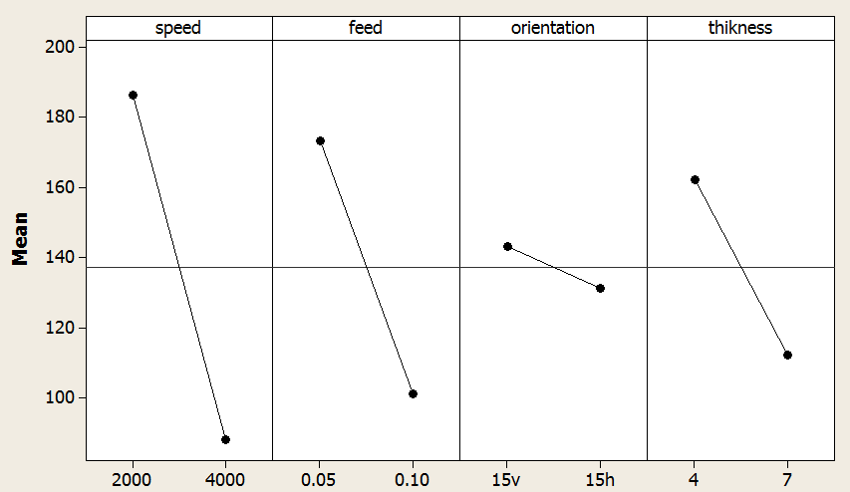Fig. 4.2 Main Effects Plot For Fx

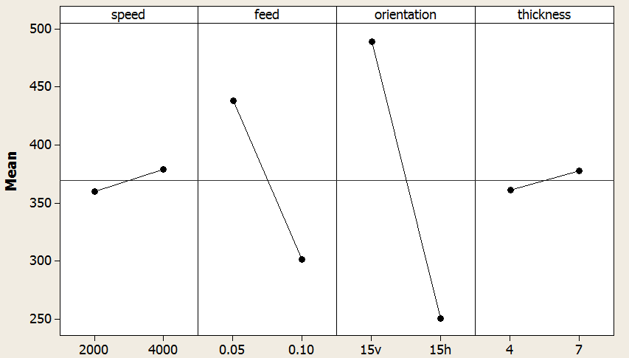

Fig 4.3 Main Effects plot For Fy

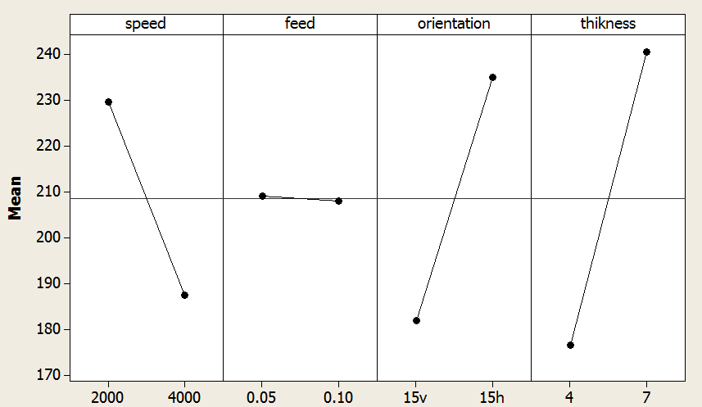

Fig 4.4 Main Effects plot For Fz

**4.1.2 Analysis of main effect plots for forces at 150orientation.**

* As the speed increases the forces are reduced as shown in figure 4.2 and 4.3.The decrement in the machining forces is due to thermal softening .This results ineasy material removal at higher rate .As speed increases the vibrations are reduced resulting in smooth operation.But as the speed increases the axial force Fz increases.
* As the feed increases from 0.05mm/tooth to 0.1mm/tooth the forces Fy and Fz decreases as shown in fig.4.3 and fig. 4.4 while Fx remains steadyas shown in fig.4.2.as the feed increases the amount of material fed to each tooth increase results in higher removal rate combined with increase in vibration.
* The forces Fy and Fz are maximum for vertical milling and minimum for horizontal milling as shown in fig.4.3 and fig.4.4.This is due to higher deflection and less contact time .But tangential force is maximum in horizontal milling and minimum in vertical milling.
* As thickness increases from 4 mm to 7 mm the axial and tangential force increases while there is decrement in radial force as shown in fig.4.2,fig 4.3 and fig 4.4.As thickness increases rigidity increases ,deflection simultaneously decreases.

Table 4.5 ANOVA of RaF

|  |  |  |  |  |  |
| --- | --- | --- | --- | --- | --- |
| Source | DF | Seq SS | Adj MS | F | P |
| Speed | 1 | 2.5425 | 2.5425 | 17.94 | 0.024 |
| Feed | 1 | 0.5050 | 0.5050 | 3.56 | 0.155 |
| Orientation | 1 | 0.9591 | 0.9591 | 6.77 | 0.080 |
| Thickness | 1 | 2.6106 | 2.6106 | 18.42 | 0.023 |
| Error | 3 | 0.4251 |  |  |  |
| Total | 7 | 7.0424 |  |  |  |
| S = 0.376447 R-Sq = 93.96% R-Sq(adj) = 85.91% | | | | | |

Table 4.6 ANOVA of RaM

|  |  |  |  |  |  |
| --- | --- | --- | --- | --- | --- |
| Source | DF | Seq SS | Adj MS | F | P |
| Speed | 1 | 0.03521 | 0.03521 | 0.29 | 0.626 |
| Feed | 1 | 0.0036 | 0.0036 | 0.03 | 0.873 |
| Orientation | 1 | 0.0703 | 0.0703 | 0.59 | 0.500 |
| Thickness | 1 | 2.6796 | 2.6796 | 22.31 | 0.018 |
| Error | 3 | 0.3603 | 0.1201 |  |  |
| Total | 7 |  |  |  |  |
| S = 0.346573 R-Sq = 88.56% R-Sq(adj) = 73.30% | | | | | |
|  | | | | | |

Table 4.7 ANOVA OF RaE

|  |  |  |  |  |  |
| --- | --- | --- | --- | --- | --- |
| Source | DF | Seq SS | Adj MS | F | P |
| Speed | 1 | 0.4278 | 0.4278 | 1.96 | 0.256 |
| Feed | 1 | 2.7495 | 2.7495 | 12.57 | 0.038 |
| Orientation | 1 | 0.5778 | 0.5778 | 2.64 | 0.23 |
| Thickness | 1 | 1.7766 | 1.7766 | 8.12 | 0.065 |
| Error | 3 | 0.6564 | 0.2188 |  |  |
| Total | 7 | 6.1882 |  |  |  |
| S = 0.467774 R-Sq = 89.39% R-Sq(adj) = 75.25% | | | | | |

**4.1.3 ANOVA analysis for surface roughness with 150orientation.**

* Refering table 4.5 the P values for thickness and speed is less than 0.05 hence ther impact on surface roughness at fix end (RaF) is maximum as compared to other factors.This is because speed and thickness has its effect on vibration
* From table 4.6 as the P value for the thickness is 0.018 ,it is lower than 0.05 it affects to maximum extent on RaM.
* From table 4.7 P value for feed is 0.038, its effect on RaE is maximum .As the feed increases the RaE increases due to increase in material removal rate and frictional forces.

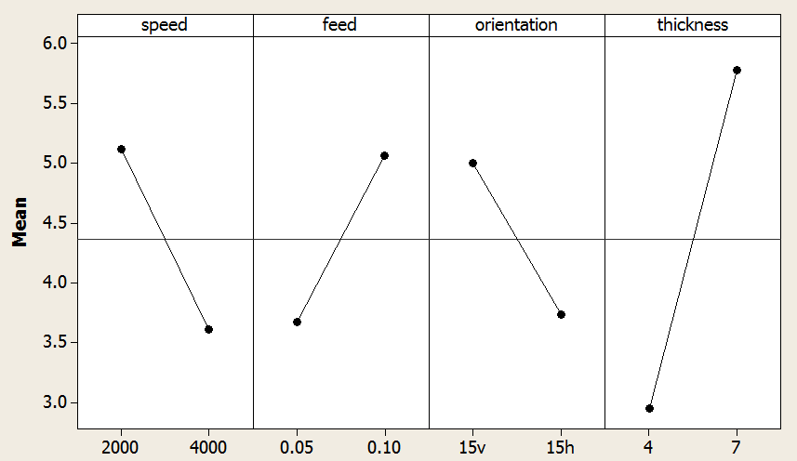

Fig 4.5 Main effects plot for RaF

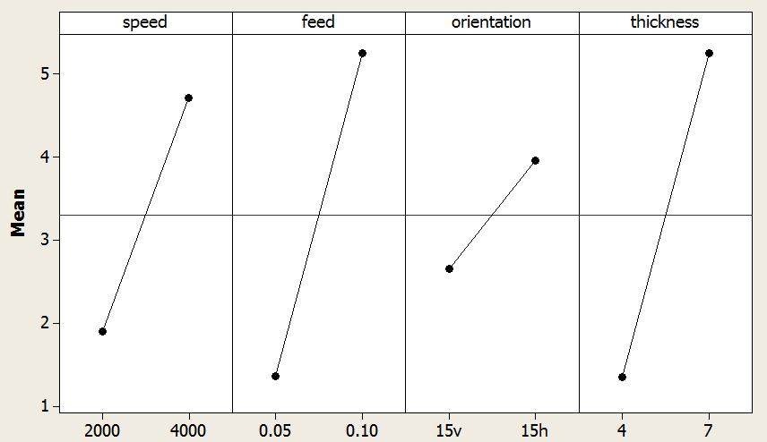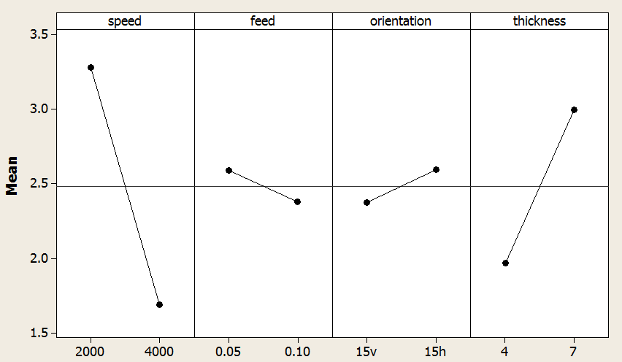

Fig 4.6 Main effects plot for RaE

Fig 4.7Main effects plot for RaM

**4.1.4 Analysis of main effect plots for surface roughness at 150orientation.**

* As the speed increases from 2000 rpm to 4000 rpm the surface roughness gets reduced at fixed and at end section as shown in figure 4.5, and fig.46.The decrement in the surface roughness is due to thermal softening .This results ineasy material removal at higher rate .As speed increases the vibrations are reduced resulting in smooth operation .
* As the feed increases from 0.05mm/tooth to 0.1mm/tooth the surface roughness increases at fixed and middle section as shown in fig.4.5 and fig.4.7, while at end section surface roughness decreases with increasing speed .as shown in fig 4.6.ASs the feed increases the amount of material fed to each tooth increase results in higher removal rate combined with increase in vibration.
* The surface roughness is maximum for horizontal milling and minimum for vertical milling as shown in fig.4.6 , fig 4.7 .This is due to higher deflection and less contact time .
* As thickness increases from 4 mm to 7 mm the surface roughness increases as shown in fig4.5, fig4.6 and fig4.7..This is because as thickness increases rigidity increases ,deflection simultaneously decreases.

**4.2 4.2 Statistical Analysis of Surface RoughnessRa and forces for 45º inclination**

|  |  |  |  |  |  |  |  |  |  |
| --- | --- | --- | --- | --- | --- | --- | --- | --- | --- |
| Speed  (rpm) | Feed  (mm/tooth) | Orientation  (º) | Thickness  (mm) | RaF  (µm) | RaM  (µm) | RaE  (µm) | Fx  N/V | Fy  N/V | Fz  N/V |
| 2000 | 0.05 | 45v | 4 | 13.32 | 4.90 | 2.0 | 312 | 340 | 640 |
| 2000 | 0.05 | 45h | 7 | 1.69 | 1.99 | 0.68 | 180 | 180 | 156 |
| 2000 | 0.1 | 45v | 7 | 2.35 | 1.84 | 3.78 | 60 | 180 | 120 |
| 2000 | 0.1 | 45h | 4 | 2.08 | 4.68 | 1.51 | 70 | 74 | 136 |
| 4000 | 0.05 | 45v | 7 | 2.69 | 2.25 | 2.39 | 62 | 44 | 92 |
| 4000 | 0.05 | 45h | 4 | 6.06 | 6.4 | 1.65 | 60 | 90 | 90 |
| 4000 | 0.1 | 45v | 4 | 3 | 4.73 | 1.85 | 66 | 68 | 128 |
| 4000 | 0.1 | 45h | 7 | 4.59 | 3.05 | 4.55 | 80 | 60 | 160 |

Table 4.8 Response of surface roughness and forces with 45º

RaF=Surface roughness at fixed end Fx=Tangential force

RaM= Surface roughness at middle Fy=Radial force

RaE= Surface roughness at end Fz=Axial force

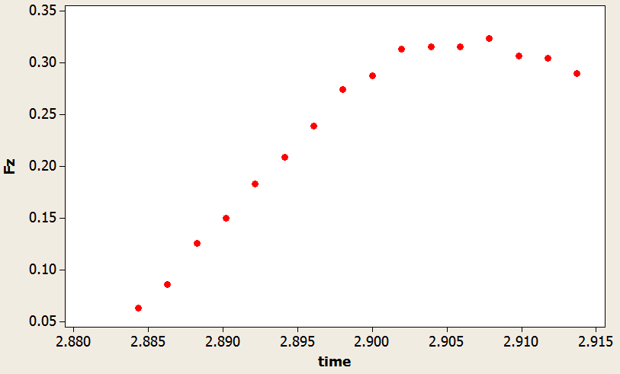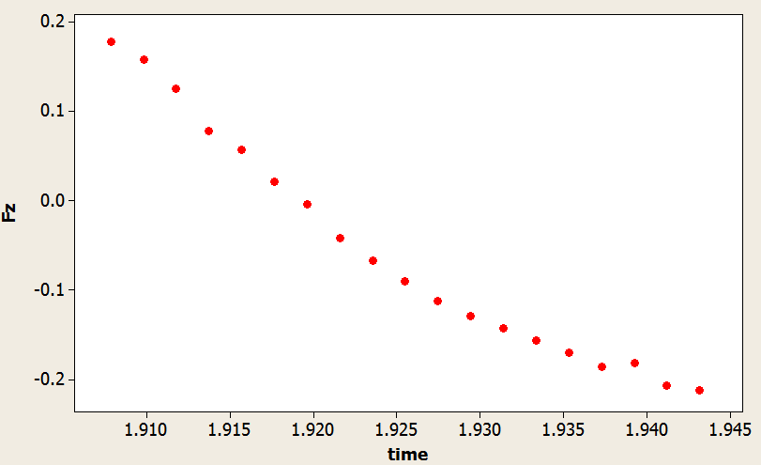

Graph 4.3 Fz V Time in 45º inclination Graph 4.4 Fz V Time in 45º inclination

Table 4.9 ANOVA of Fx

|  |  |  |  |  |  |
| --- | --- | --- | --- | --- | --- |
| Source | DF | Seq SS | Adj MS | F | P |
| Speed | 1 | 1352 | 1352 | 3.20 | 0.1720 |
| Feed | 1 | 6384 | 6384 | 15.09 | 0.03 |
| orientation | 1 | 480 | 481 | 1.14 | 0.365 |
| thickness | 1 | 57800 | 57800 | 136.64 | 0.001 |
| Error | 3 | 1269 | 423 |  |  |
| Total | 7 | 67286 |  |  |  |
| S = 29.5670 R-Sq = 98.11% R-Sq(adj) = 95.60% | | | | | |

Table 4.10 ANOVA of Fy

|  |  |  |  |  |  |
| --- | --- | --- | --- | --- | --- |
| Source | DF | Seq SS | Adj MS | F | P |
| Speed | 1 | 43218 | 43218 | 29.38 | 0.012 |
| Feed | 1 | 242 | 242 | 0.16 | 0.712 |
| orientation | 1 | 7812 | 7812 | 5.31 | 0.105 |
| thickness | 1 | 181 | 181 | 0.12 | 0.749 |
| Error | 3 | 4412 | 1417 |  |  |
| Total | 7 | 76111 |  |  |  |
| s = 38.3514 R-Sq = 92.10% R-Sq(adj) = 81.57% | | | | | |

Table 4.11 ANOVA of Fz

|  |  |  |  |  |  |
| --- | --- | --- | --- | --- | --- |
| Source | DF | Seq SS | Adj MS | F | P |
| Speed | 1 | 25088.0 | 25088.0 | 30.72 | 0.012 |
| Feed | 1 | 98 | 98 | 0.12 | 0.752 |
| orientation | 1 | 512 | 512 | 0.63 | 0.486 |
| thickness | 1 | 242 | 242 | 0.30 | 0.624 |
| Error | 3 | 2450 | 816.7 |  |  |
| Total | 7 |  |  |  |  |
| S = 28.5774 R-Sq = 91.37% R-Sq(adj) = 79.86% | | | | | |

**4.2.1 ANOVA analysis of forces with 450orientation**

* Referingtable 4.9 as the P value of thickness is the less than 0.05, its impact on Fx value is maximum.Thickness affects the rigidity and deflection thus affects Fx.
* From table 4.10 the impact of speed is maximum on Fy as P value is minimum for speed factor as compare to other factors. This is due to increase in vibration and higher material removal rate in radial direction.
* From table 4.11 the P value for speed is minimum i.e 0.012 so its impact on Fz is maximum as compare to other factor .Speed has its impact on vibration and hence the Fz forces in axial direction.

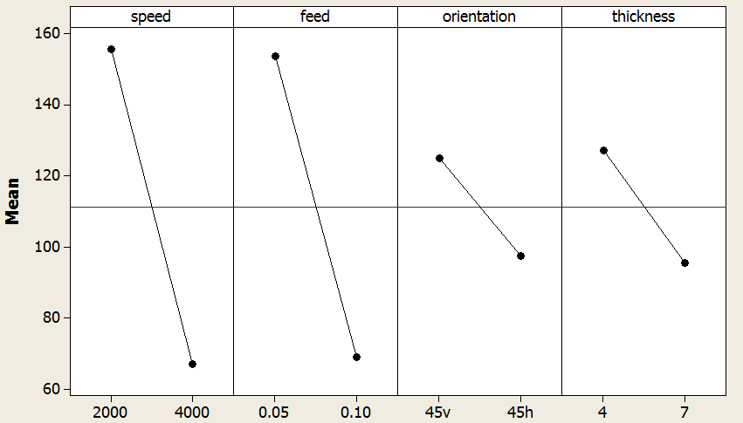

Fig 4.8 Main effects plot for Fx

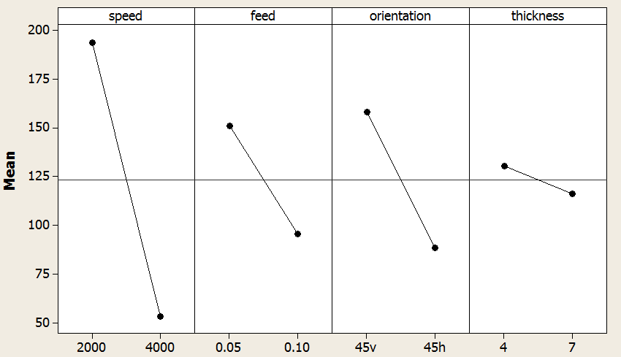

Fig 4.9 Main effects plot for Fy

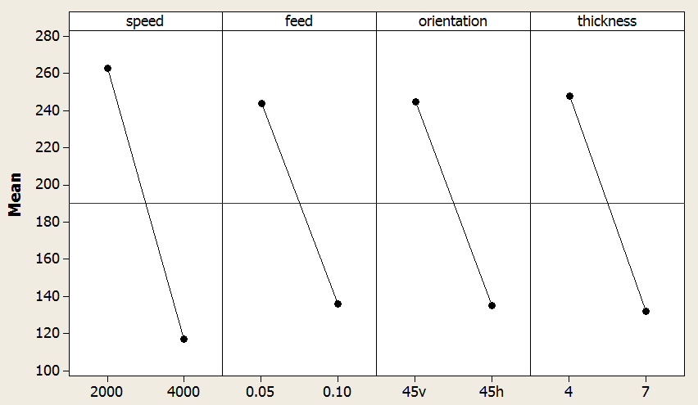

Fig 4.10 Main effects plot for Fz

**4.2.2 Analysis of main effect plots for forces at 450orientation.**

* As the speed increases from 2000 rpm to 4000 rpm the forces arereduced as shown in figure 4.8, fig 4.9and fig.4.10.The decrement in the machining forces is due to thermal softening .This results ineasy material removal at higher rate .As speed increases the vibrations are reduced resulting in smooth operation .
* As the feed increases from 0.05mm/tooth to 0.1mm/tooth the forcesFx,Fy and Fz decreases as shown in fig.4.8 , fig. 4.9 and fig.4.10, while .ASs the feed increases the amount of material fed to each tooth increase results in higher removal rate combined with increase in vibration.
* The forcesFx,Fy and Fz are maximum for vertical milling and minimum for horizontal milling as shown in fig.4.8,fig 4.9 and fig.4.10.This is due to higher deflection and less contact time .
* As thickness increases from 4 mm to 7 mm the axial, radial and tangential force decreases. This is because as thickness increases rigidity increases ,deflection simultaneously decreases.

Table 4.11 ANOVA of RaF

|  |  |  |  |  |  |
| --- | --- | --- | --- | --- | --- |
| Source | DF | Seq SS | Adj MS | F | P |
| Speed | 1 | 0.00211 | 0.00211 | 0.20 | 0.688 |
| Feed | 1 | 0.67861 | 0.67861 | 63.15 | 0.004 |
| orientation | 1 | 1.97011 | 1.97011 | 183.34 | .001 |
| thickness | 1 | 0.10811 | 0.10811 | 10.06 | 0.050 |
| Error | 3 | 0.03224 | 0.01075 |  |  |
| Total | 7 | 2.79119 |  |  |  |
| S = 0.103662 % R-Sq(adj) = 97.31% R-Sq = 98.85 | | | | | |

Table 4.12 ANOVA of RaM

|  |  |  |  |  |  |
| --- | --- | --- | --- | --- | --- |
| Source | DF | Seq SS | Adj MS | F | P |
| Speed | 1 | 0.0013 | 0.0013 | 0.01 | 0.934 |
| Feed | 1 | 0.3532 | 0.3532 | 2.25 | 0.231 |
| orientation | 1 | 0.0514 | 0.0514 | 0.33 | 0.608 |
| thickness | 1 | 9.1186 | 9.1186 | 58.03 | 0.005 |
| Error | 3 | 0.4714 | 0.1571 |  |  |
| Total | 7 | 9.9958 |  |  |  |
| S = 0.396392 R-Sq = 95.28% R-Sq(adj) = 89.00% | | | | | |

Table 4.13 ANOVA of RaE

|  |  |  |  |  |  |
| --- | --- | --- | --- | --- | --- |
| Source | DF | Seq SS | Adj MS | F | P |
| Speed | 1 | 0.1568 | 0.1568 | 4.47 | 0.125 |
| Feed | 1 | 0.6844 | 0.6844 | 19.50 | 0.022 |
| orientation | 1 | 0.0612 | 0.0613 | 1.75 | 0.278 |
| Thickness | 1 | 5.6448 | 5.6448 | 160.82 | 0.001 |
| Error | 3 | 0.1053 | 0.0351 |  |  |
| Total | 7 | 6.6526 |  |  |  |
| S = 0.187350 R-Sq = 98.42% R-Sq(adj) = 96.31% | | | | | |

**4.2.3 ANOVA analysis for surface roughness with 450orientation**

* Referring table 4.11 the P values of feed and orientation is minimum with respect to other factors. So the impact of feed and orientation is maximum on RaF .Orientation has its effects because of lower orientation angle as the tooth nose tip is in contact with workpiece while for higher orientation angle tooth periphery is in contact with workpiece.
* From table 4.12 thickness value of P i.e 0.004 which is less than 0.05 affects RaM to larger extent .This effect is due to rigidity factor.
* Referring table 4.13 as the P values of thickness affects the RaE value to large extent .The effect is due to deflection in workpiece. The reliability of RaE on thickness is 98%.

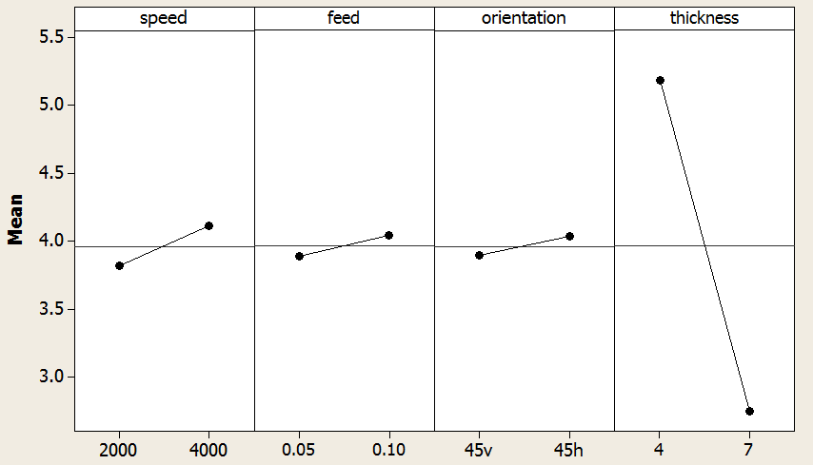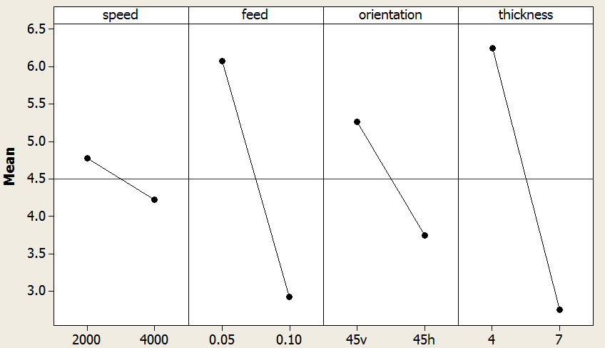Fig 4.11 Main effect plot for RaF

Fig 4.12 Main effect plot for RaM

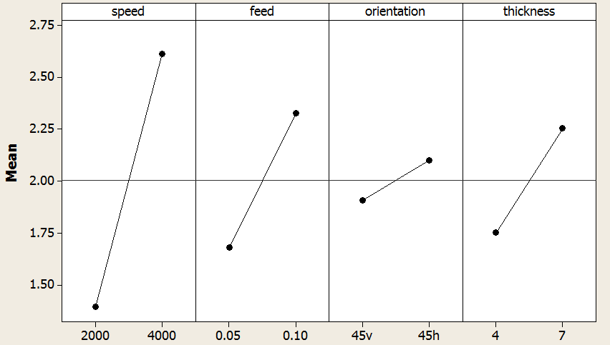

Fig 4.13 Main effect plot for RaE

**4.2.4 Analysis of main effect plots for surface roughness at 450orientation.**

* As the speed increases from 2000 rpm to 4000 rpm the surface roughness at middle and end section increases while decreases at fixed section as shown in figure 4.11, fig 4.12 and fig.4.13.The decrement in the machining forces is due to thermal softening .This results ineasy material removal at higher rate .As speed increases the vibrations are reduced resulting in smooth operation .
* As the feed increases from 0.05mm/tooth to 0.1mm/tooth surface roughness remains constant at middle section, decreases at fixed section and increase at end section as shown in fig.4.11, fig. 4.12 and fig.4.13., while As the feed increases the amount of material fed to each tooth increase results in higher removal rate combined with increase in vibration.
* The surface roughness maximum for horizontal milling at middle and end section .while minimum for horizontal milling at fixed section as shown in fig 4.11,fig4.12 and fig4.13 .This is due to higher deflection and less contact time .
* As thickness increases from 4 mm to 7 mm the surface roughness is increases at end section and decreases at fixed and middle section. This is because as thickness increases rigidity increases ,deflection simultaneously decreases.

**CHAPTER NO 5**

**CONCLUSIONS**

* Workpiece needs heat treatment to reduce the residual stresses induced in it during prior machining operations and to get uniform properties through out the material.

* As the speed increases there is decrement in the forces due to thermal softening, low vibrations and high material removal rate.
* Increase in feed increase the forces Fz and Fy while there is no effect on Fz .Its is due to high material removal rate and increased vibrations.
* As the feed increases surface roughness increases due to increased vibrations and friction.
* For higher degree of orientation the trajectory of cut is wider at the beginingand becomes narrow at the end because of higher deflection.
* For lower degree of orientation the trajectory of cut is almost uniform through out the cut due to less deflection.
* For lower degree of orientation the nose tip is in contact with the workpiece so the ploughing force is high and good surface finish is obtained.
* For high degree of orientation the periphery of the tool is in contact with workpiece so the ploughing force is low and surface finish obtained is not that good.
* As the thickness of workpiece increases with increase in in rigidity. This results in increases in forces combined by lower deflection and lower roughness value. In this case contact area is more.

**REFERENCES**

1. ASM Handbook – vol. 1, Machining, 9th edition, 1989, ASM International.
2. ASM Handbook – vol. 2, Machining, 9th edition, 1989, ASM International.
3. P. Lee, Y. Altintas, “Prediction of ball end milling forces from orthogonal cutting data”, International Journal of Machine Tool and Manufacture, 36, 1996, 1059 – 1072.
4. E.-G.Ngl, D. W. Lee, A. R. C. Sharmanl, R. C. Dewes, D. K. Aspinwal, “High Speed Ball Nose End Milling of Inconel718”, CIRP Vol. 49/1/2000.
5. F. Abrari, M. A. Elbestawi, “Closed formulation of cutting forces for ball and flat end mills”, International Journal of Machine Tool and Manufacture, 37, 1997, 17 – 27.
6. S. Kalpakjain, S. R. Schimid, Manufacturing Engineering and Technology, Pearson publication, ISBN 978-81-7758-170-6.
7. Kline, W. A., DeVor, R. E., and Shareef, I. A., 1982, “The Prediction of Surface Accuracy in End Milling,” ASME J. Eng. Ind., 104, pp. 272–278.
8. Jung, T. S., Yang, M. Y., and Lee, K. J., 2004, “A New Approach to Analysing Machined Surfaces by Ball-End Milling, Part I: Formulation of Characteristic Lines of Cut Remainder,” Adv. Manuf. Technol., 25, pp. 833–840.
9. Jung, T. S., Yang, M. Y., and Lee, K. J., 2004, “A New Approach to Analysing Machined Surfaces by Ball-End Milling, Part II: Roughness Prediction and Experimental Verification,” Adv. Manuf. Technol., 25, pp. 841–849.
10. Imani, B. M., Sadeghi, M. H., and Elbestawi, M. A., 1998, “An Improved Process Simulation System for Ball-End Milling of Sculptured Surface,” Int. J. Mach. Tools Manuf., 38, pp. 1089–1107.
11. Imani, B. M., and Elbestawi, M. A., 2001, “Geometric Simulation of Ball-End Milling Operations,” ASME J. Manuf. Sci. Eng., 123, pp. 177–184.
12. Sadeghi, M. H., Haghighat, H., and Elbestawi, M. A., 2003, “A Solid Modeler Based Ball-End Milling Process Simulation,” Int. J. Adv. Manuf. Technol., 22, pp. 775–785.